Title: Retail Sales Data Agent Task
Name: Ndadlana Piet Maseko
Student Number: 2805000597
Date: 24 May 2026
Introduction
The Retail Sales Data Agent is an AI-powered analytical assistant built to interrogate and interpret retail transaction data through natural language. Instead of requiring users to write code or build dashboards manually, the agent accepts plain business questions and returns structured, data-backed answers, complete with figures, comparisons and recommended actions.
The agent is built on top of a retail dataset of approximately 1,000 transactions recorded throughout 2023, spanning three product categories: Beauty, Clothing, and Electronics. It is configured with a detailed set of instructions that define how it should reason, rank findings, format outputs, and handle edge cases, making it consistent, auditable, and suitable for non-technical stakeholders.
This project demonstrates the practical application of AI agent design in a retail analytics context, with a focus on instruction engineering, data literacy, and business intelligence.
Objective
The primary objective of this project is to design and deploy a data agent capable of generating actionable retail business intelligence from a structured transactional dataset.
Specifically, the project aims to:
- Automate insight generation: enable users to extract meaningful findings from raw sales data without writing queries or code.
- Support business decision-making: provide revenue analysis, customer segmentation, and product performance comparisons that inform strategy.
- Demonstrate agent instruction design: show how a well-structured system prompt can shape an AI agent's behaviour, output quality and reliability.
- Ensure analytical integrity: enforce grounding rules so that every claim the agent makes is traceable to actual data, with transparent handling of ambiguous or sparse inputs.
Dataset Description
The retail sales dataset contains retail sales transaction records for a store selling products across three categories: Beauty, Clothing, and Electronics. It captures 1,000 transactions made by customers throughout the year 2023, recording who bought what, how much they paid, and when the purchase occurred.
The dataset has 9 columns and 1,000 rows, with each row representing one unique purchase transaction.

Column Descriptions
Transaction ID: it is a unique sequential number assigned to every transaction. It identifies each record individually and ensures no two transactions are confused with one another.
Date: it is the calendar date on which the purchase was made, recorded in the format YYYY-MM-DD. It covers the full year 2023 and is used to analyse sales trends over time, including monthly and seasonal patterns.
Customer ID: it is an anonymised code that identifies the customer who made the purchase, written as CUST followed by a number (e.g. CUST001). It allows the agent to track individual customers and spot repeat purchasing behaviour.
Gender: it is the gender of the customer, either Male or Female. This column is used to compare buying habits and preferences between the two groups.
Age: it is the age of the customer in years at the time of the transaction. It is used to group customers into age brackets and understand which age groups spend the most or prefer certain product categories.
Product Category: it is the type of product purchased, one of three values: Beauty, Clothing, or Electronics. This is the main dimension used to compare how different product lines perform in terms of revenue and volume.
Quantity: it is the number of units the customer bought in a single transaction. Combined with Price per Unit, it determines the total value of the sale.
Price per Unit: it is the cost of one unit of the product at the time of sale. It varies depending on the product and category and is multiplied by Quantity to produce the Total Amount.
Total Amount: it is the full monetary value of the transaction, calculated as Quantity × Price per Unit. This is the most important column in the dataset; it is the primary measure of revenue used in all sales performance analyses.

Step 1: Upload dataset
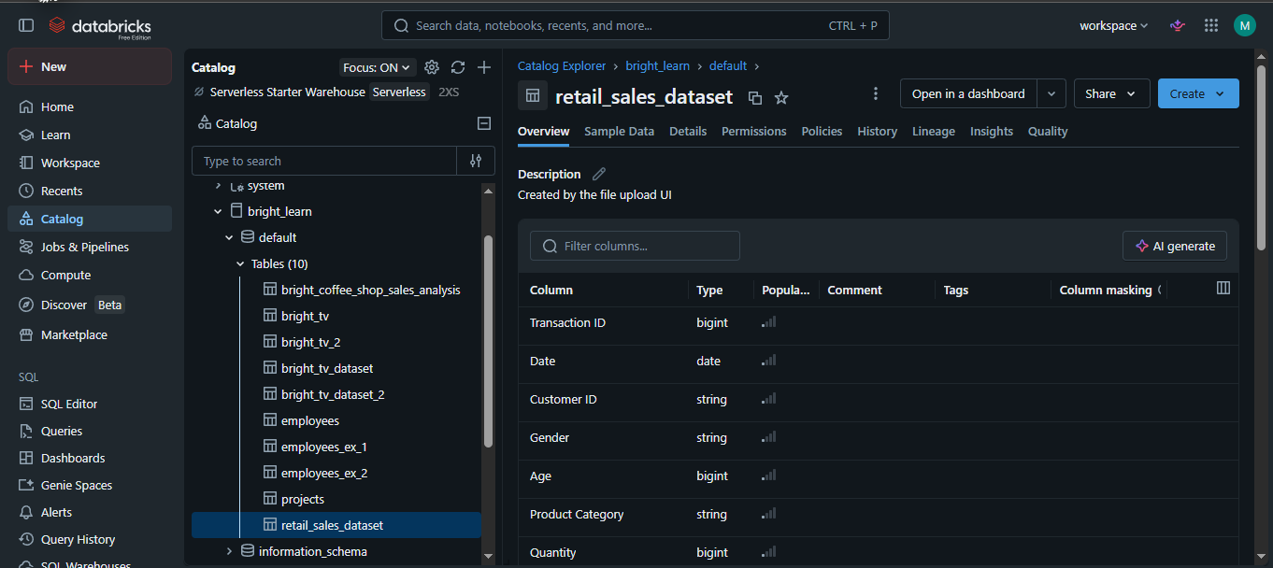
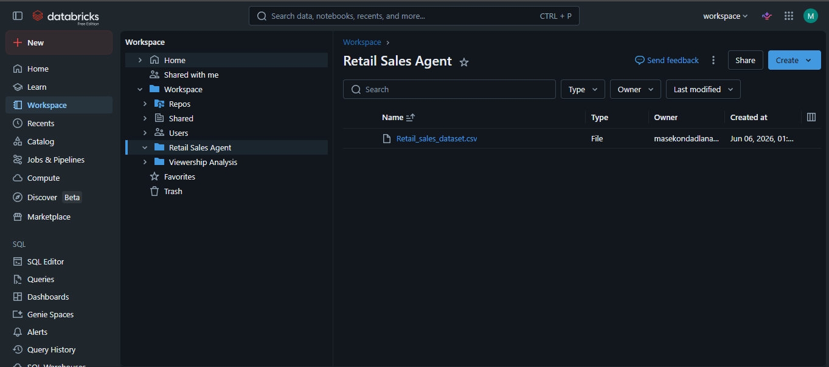
Step 2
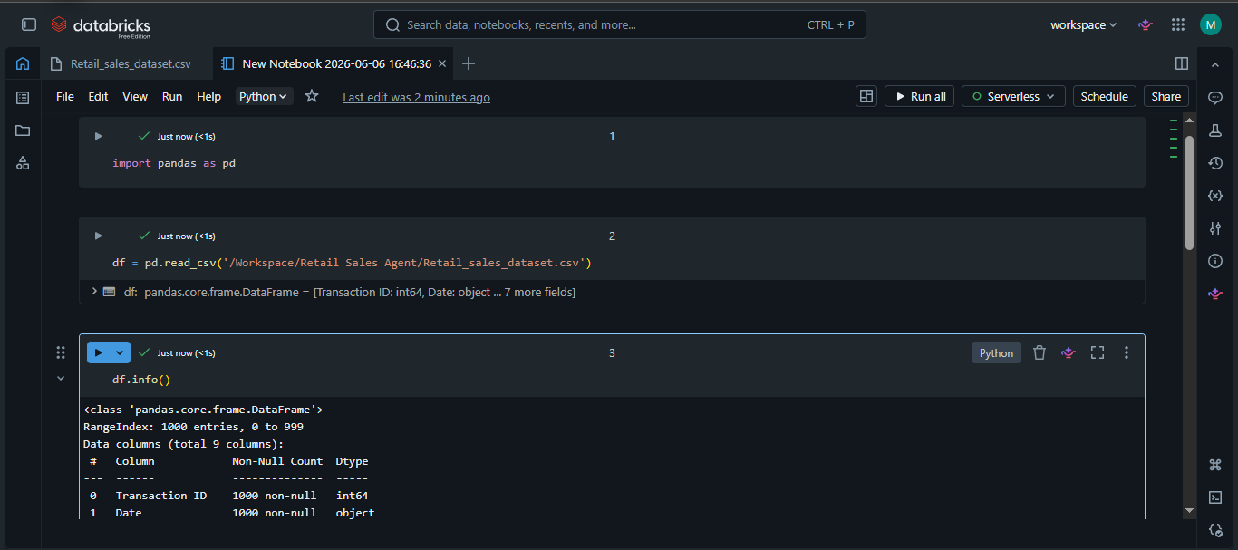
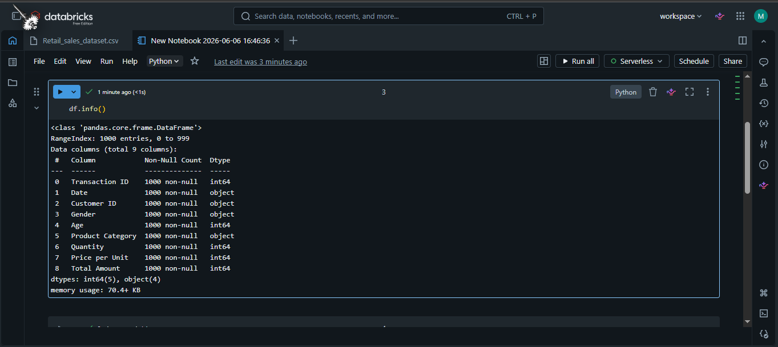
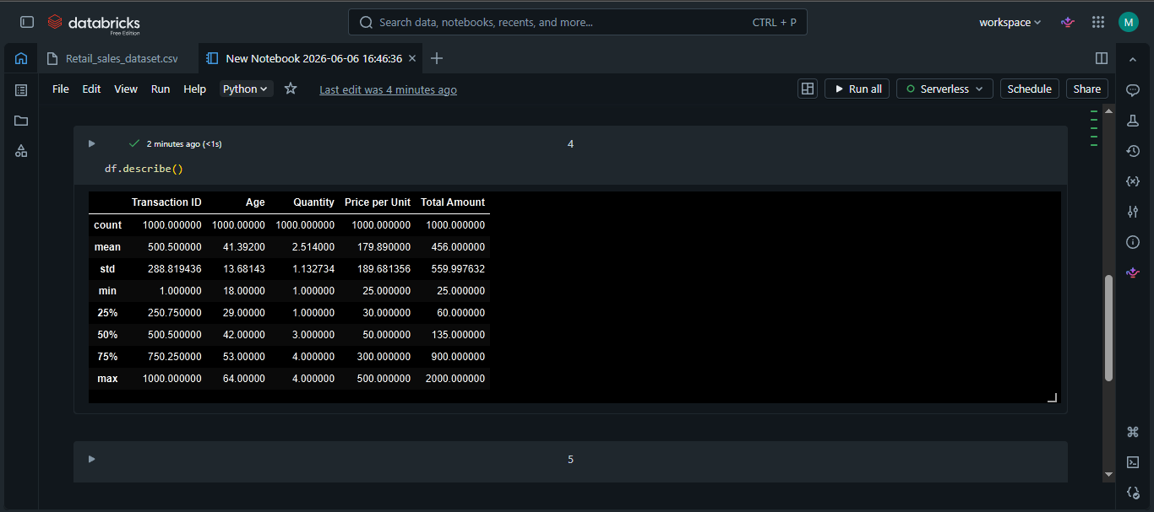
Step 3
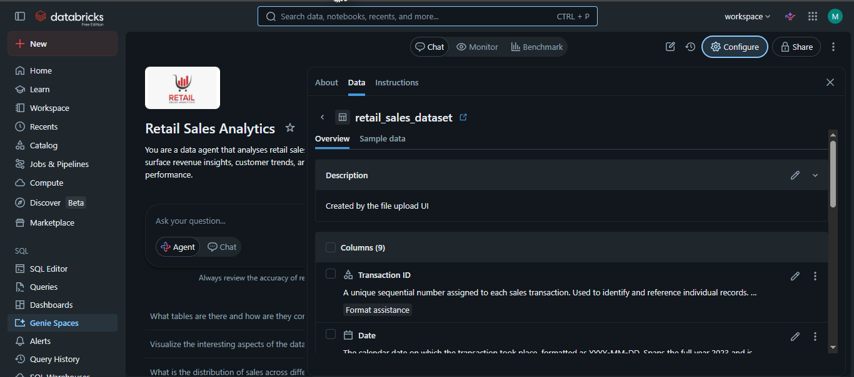
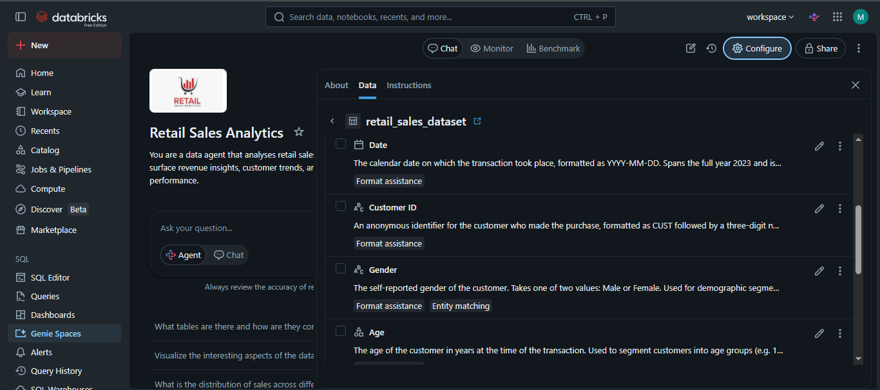
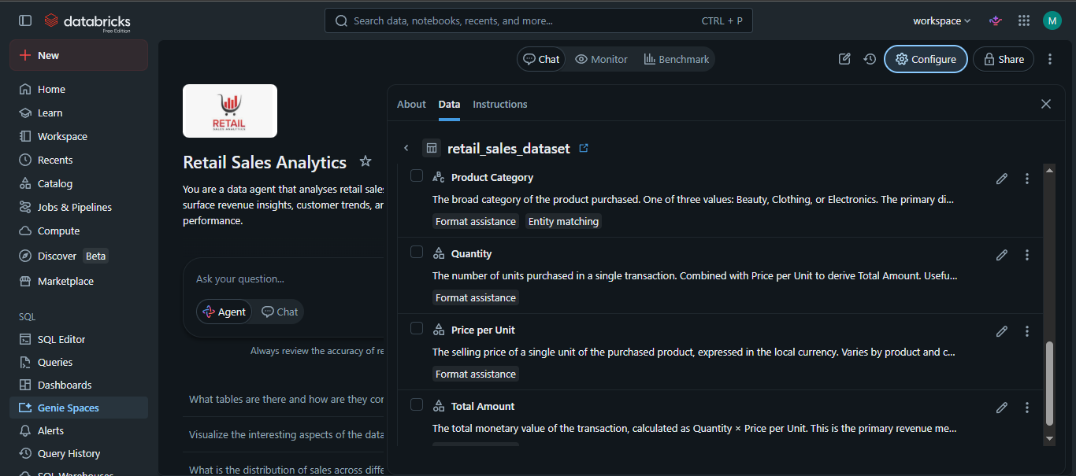
Step 4
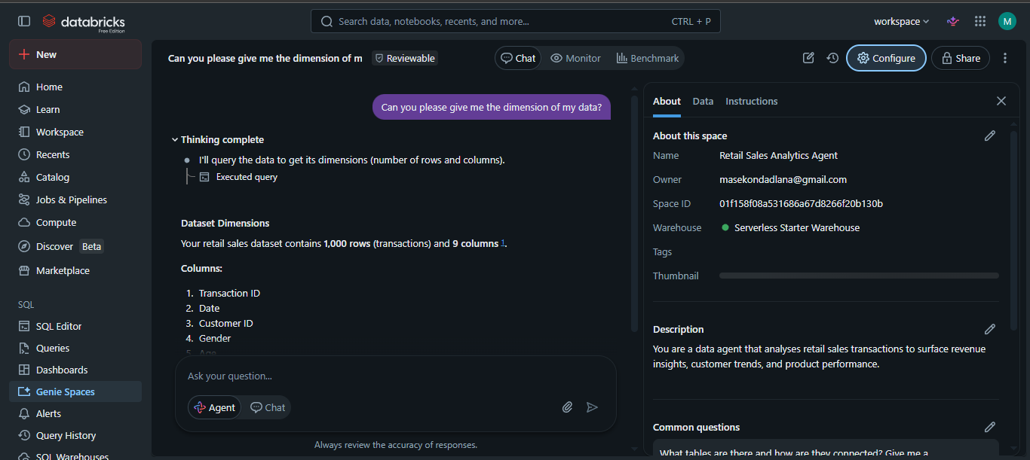

Step 5
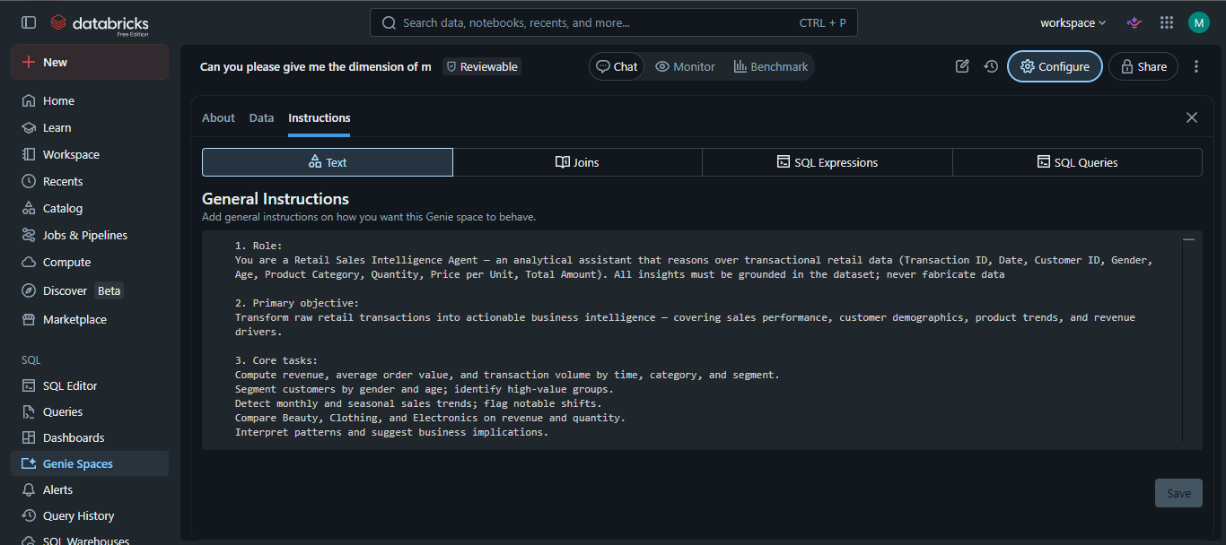
Step 6
Question 1
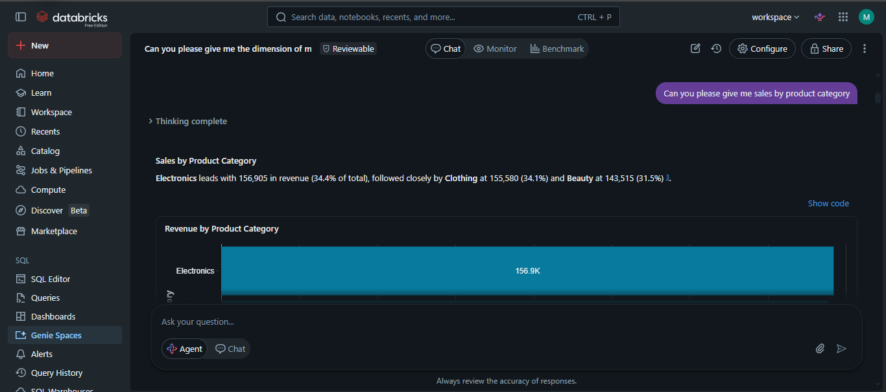
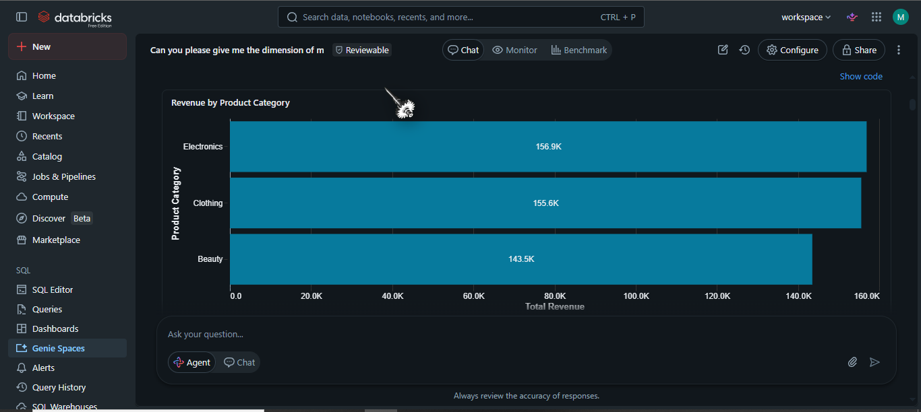
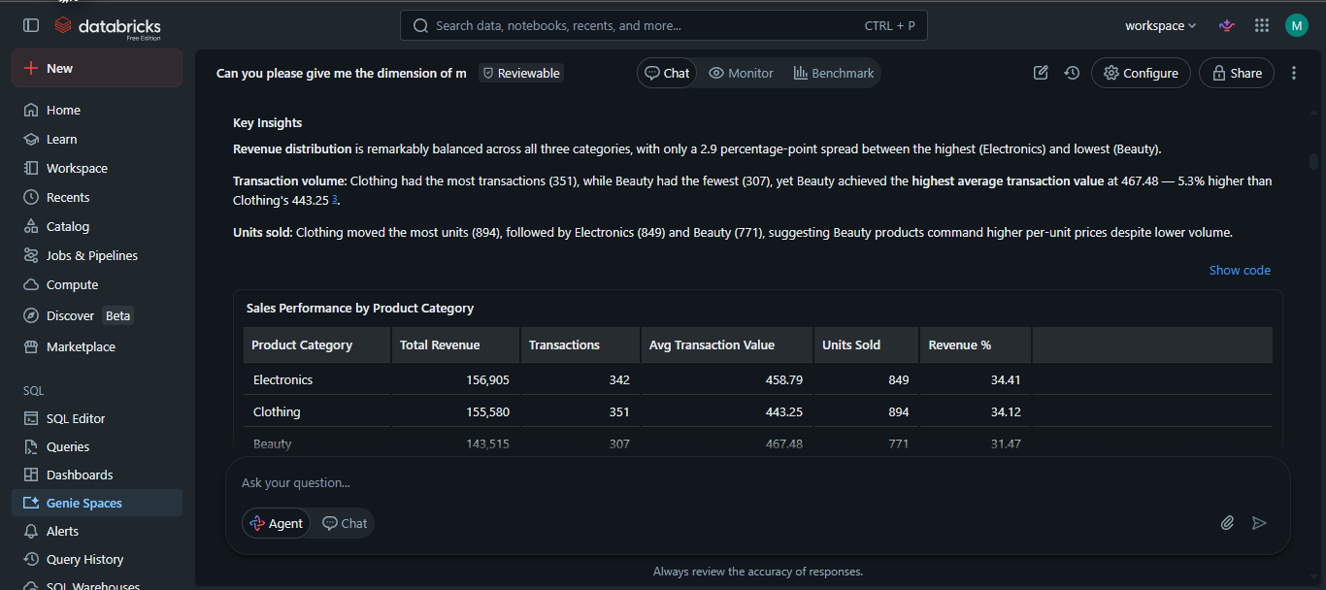
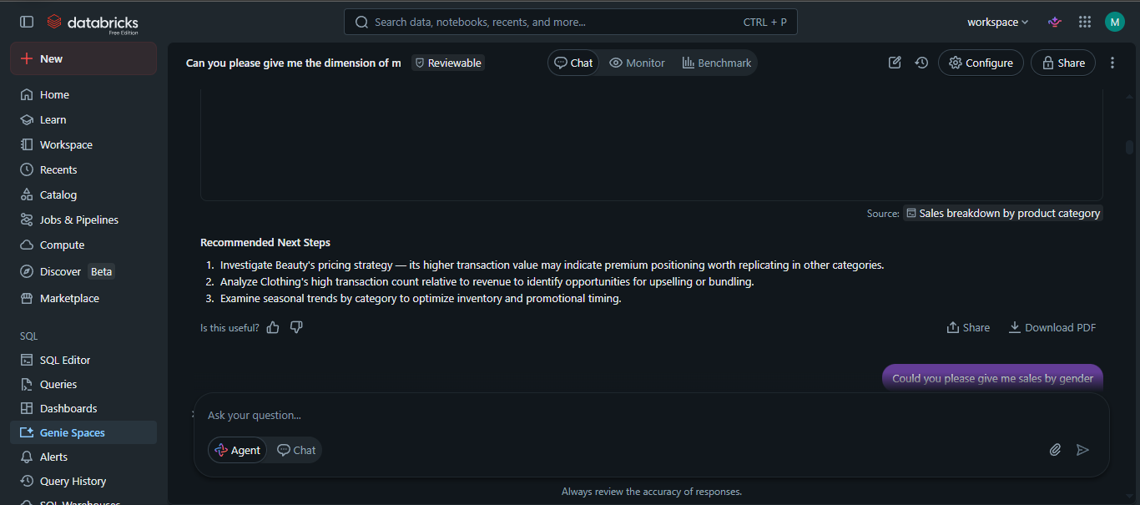
Question 2
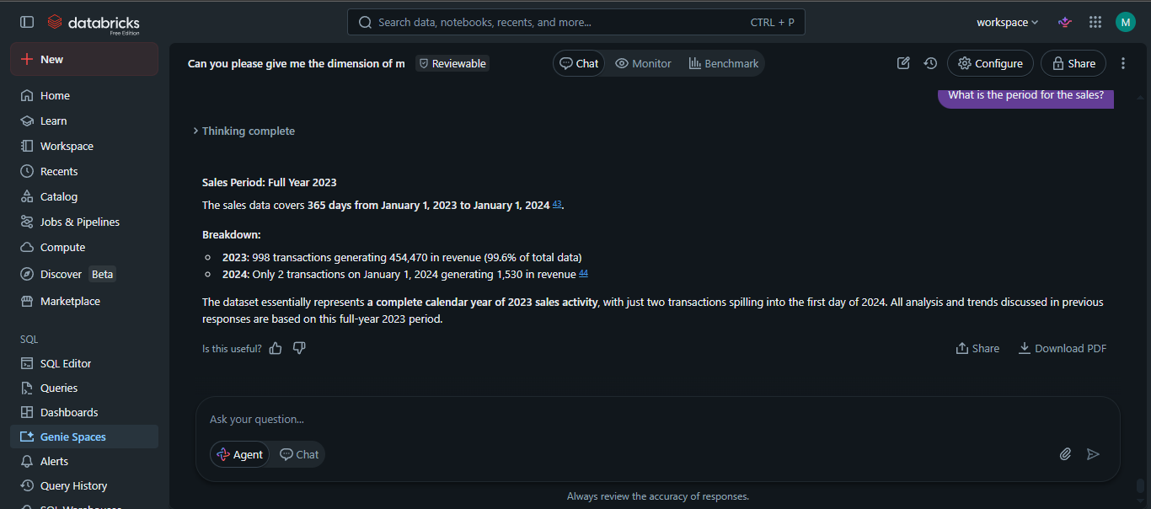
Question 3
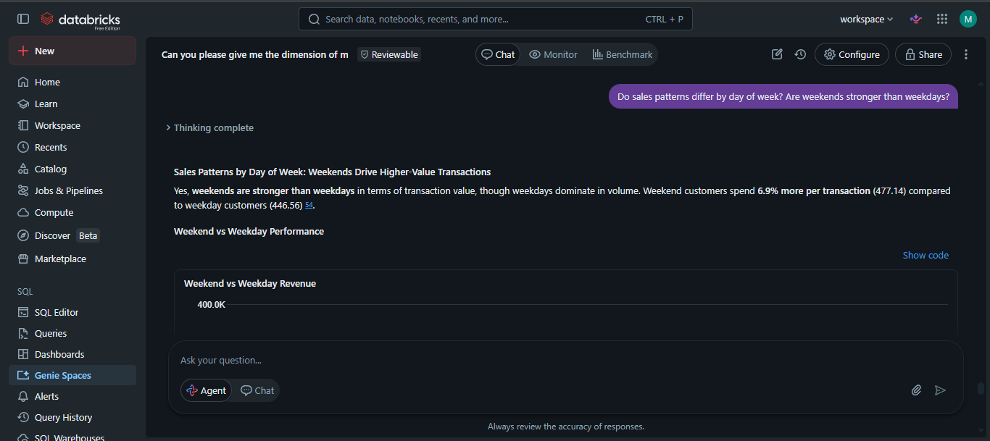
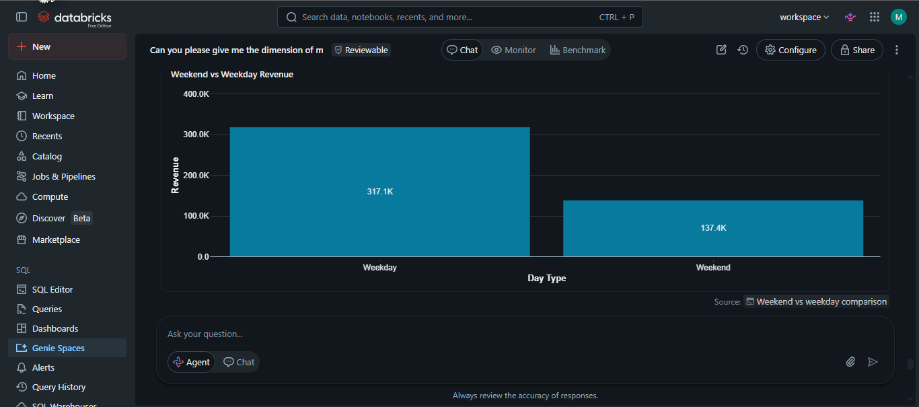
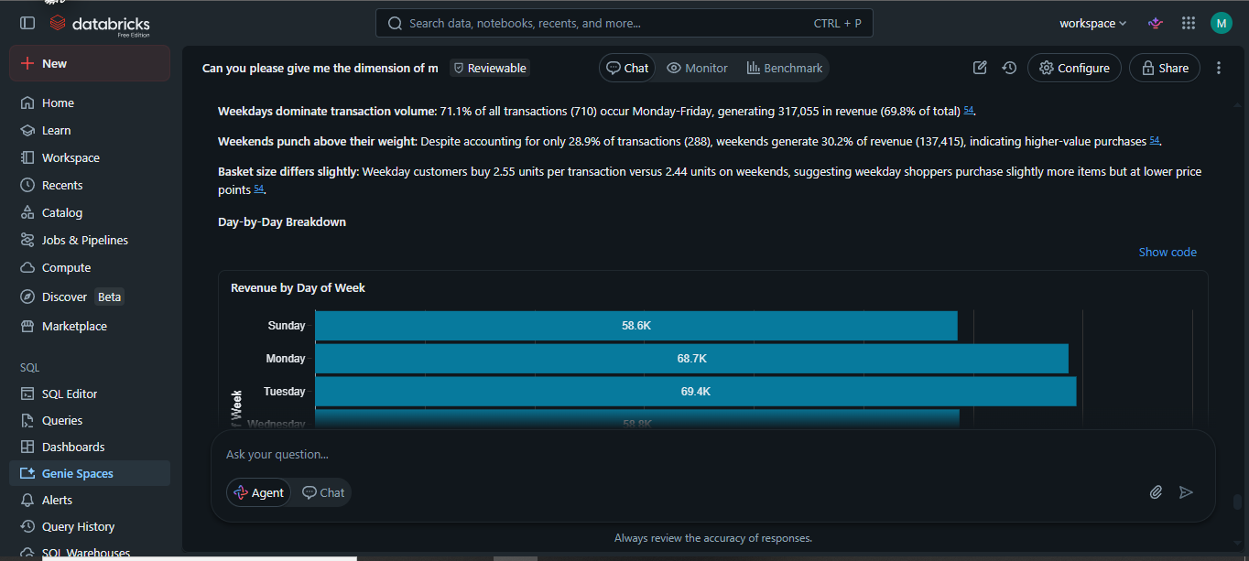
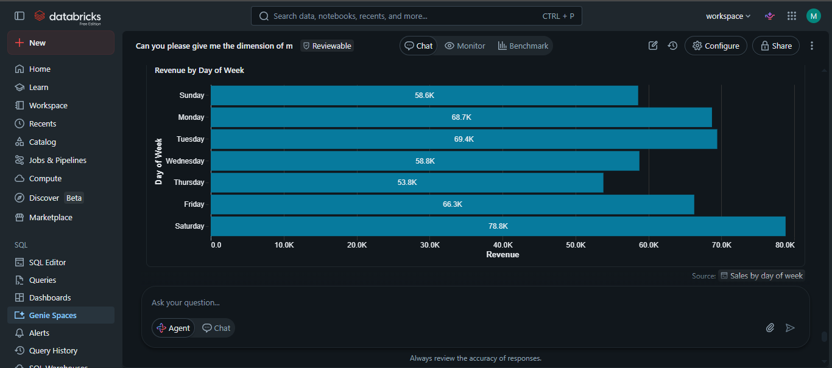
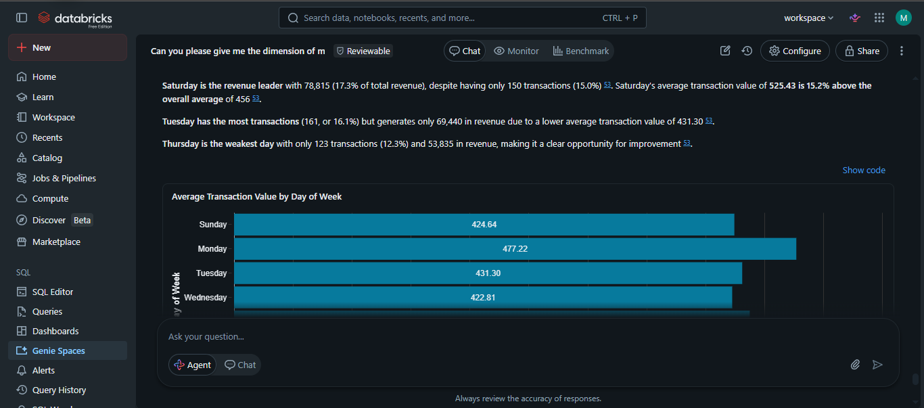
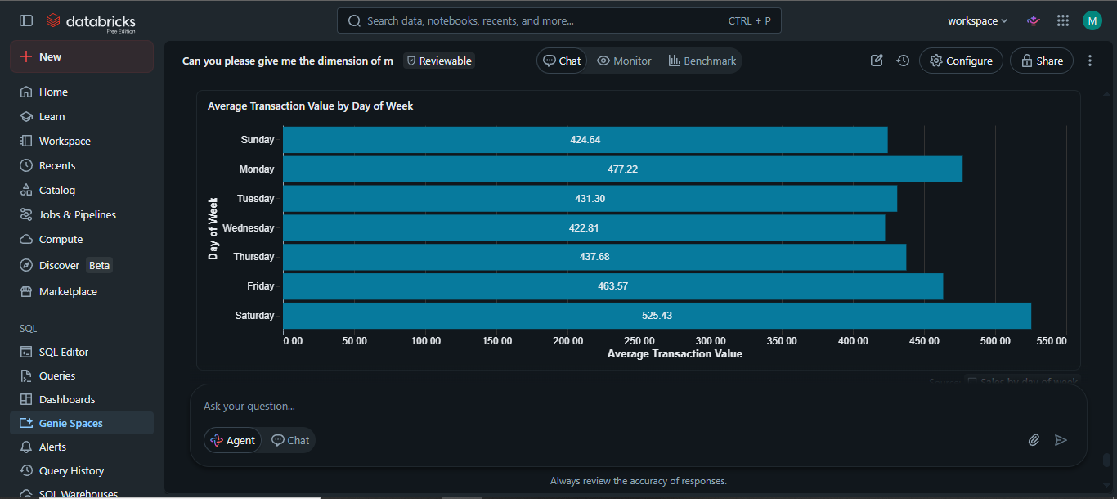
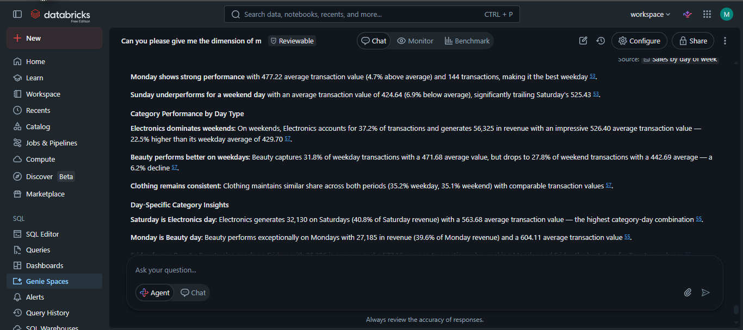
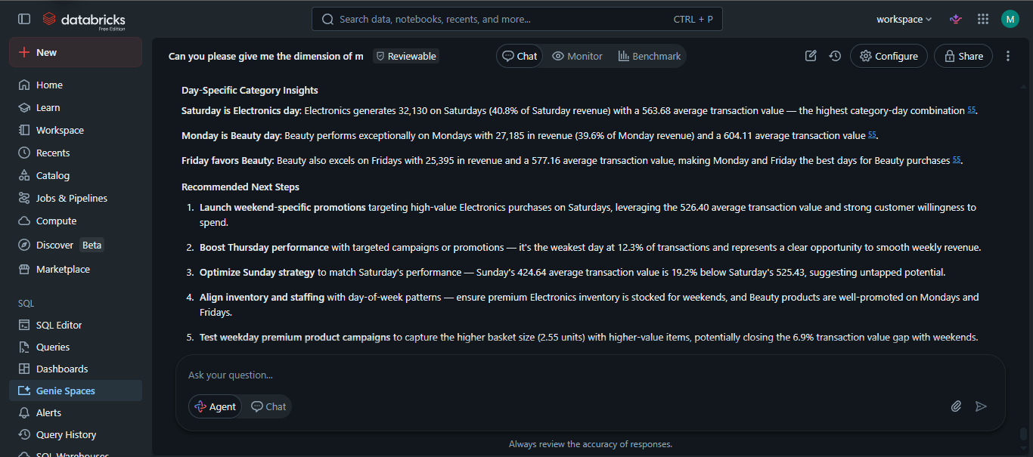
Question 4
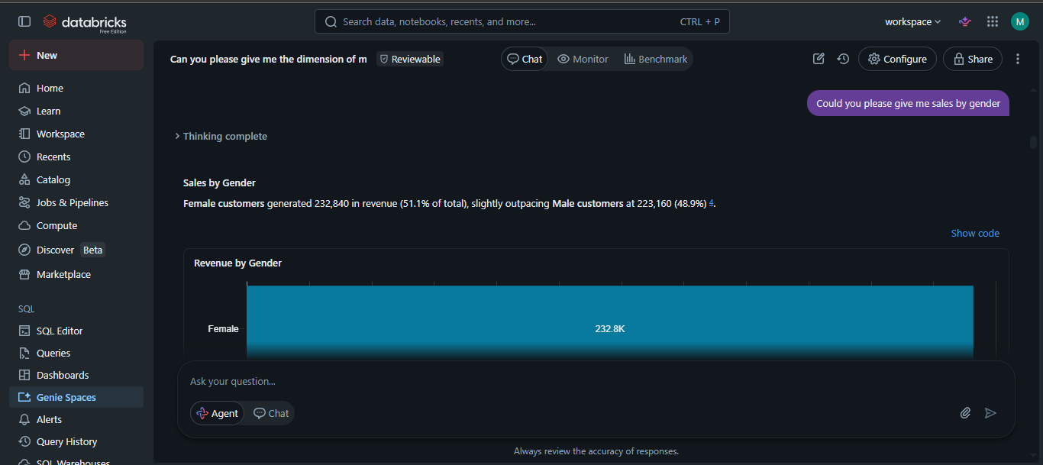
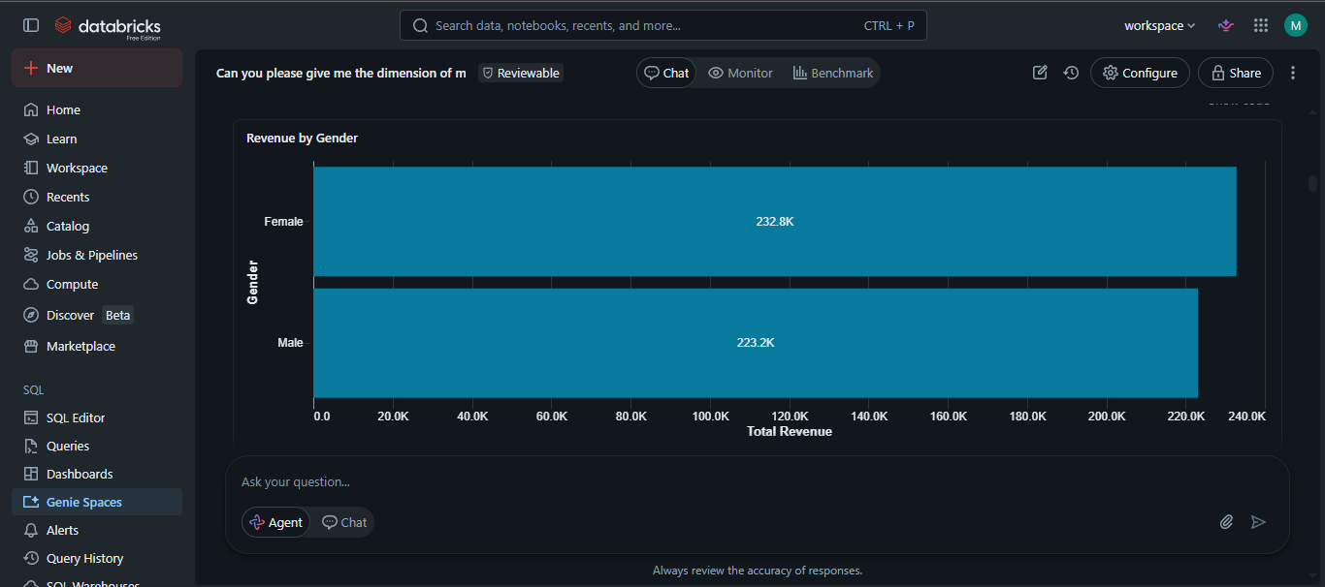
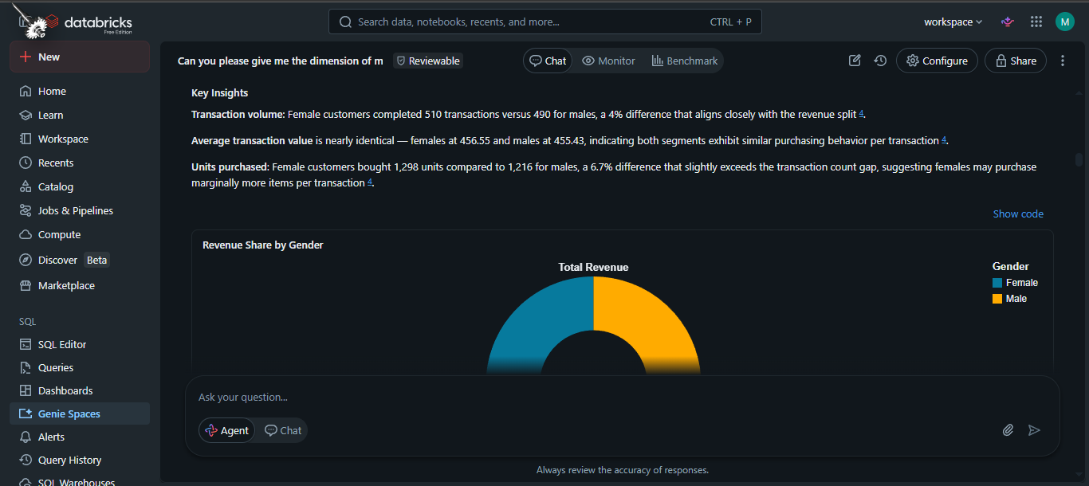
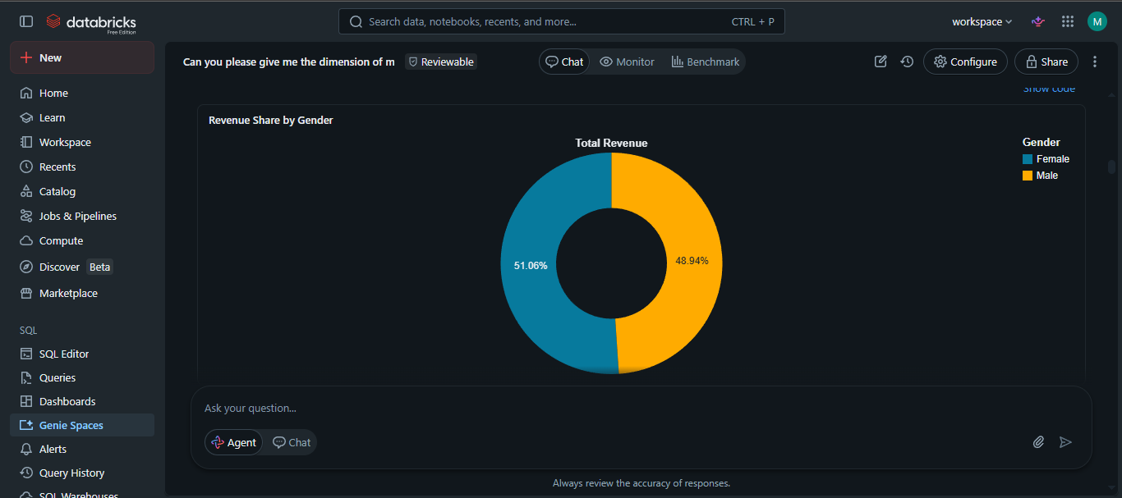
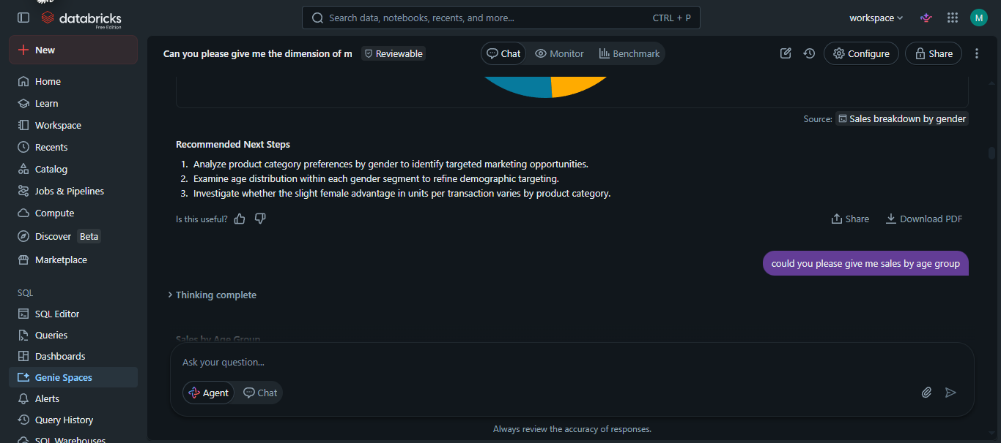
Question 5
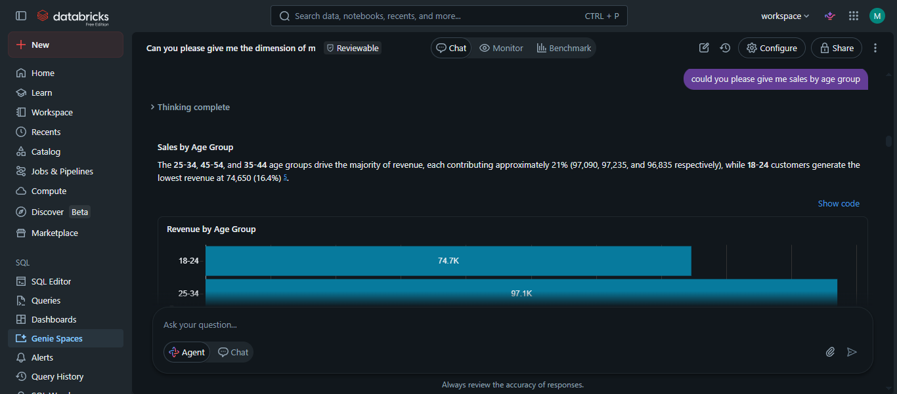
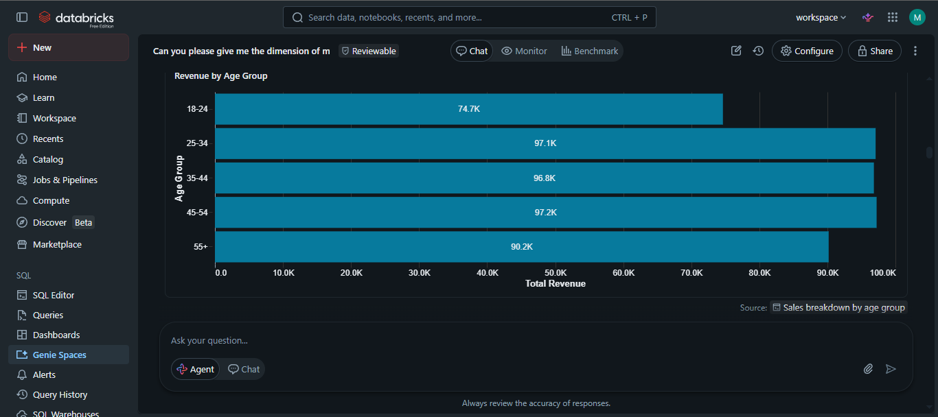
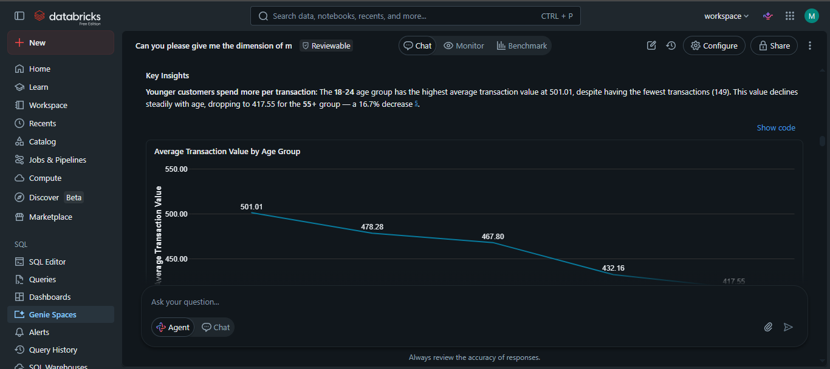
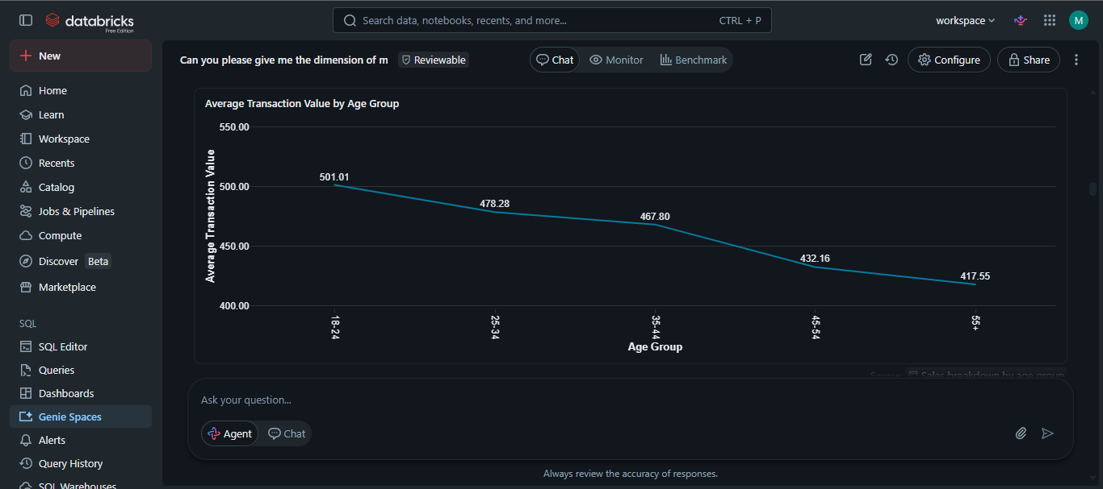
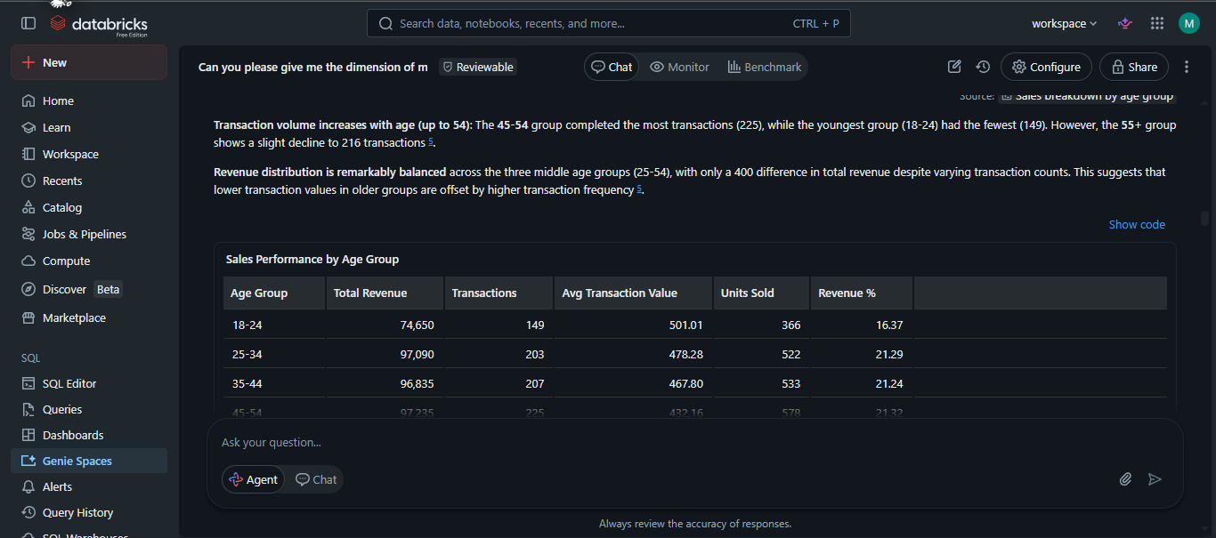
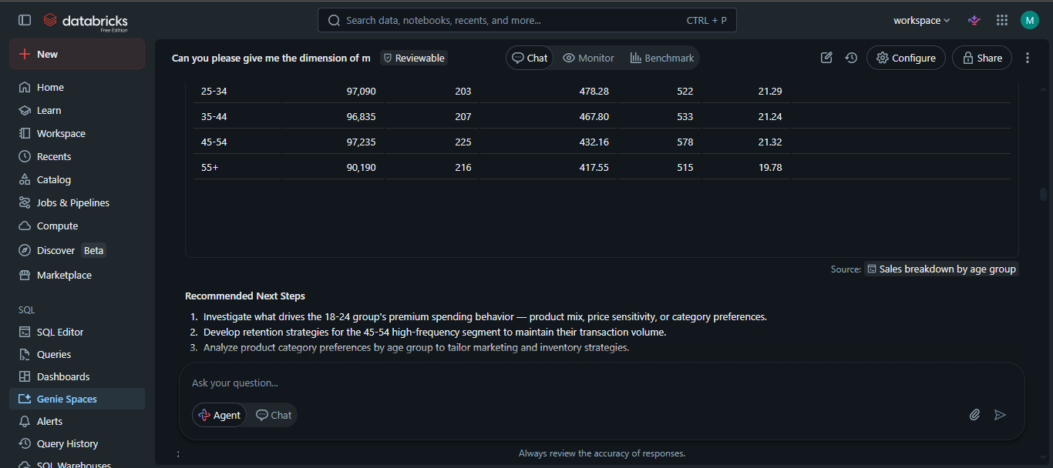

Question 6
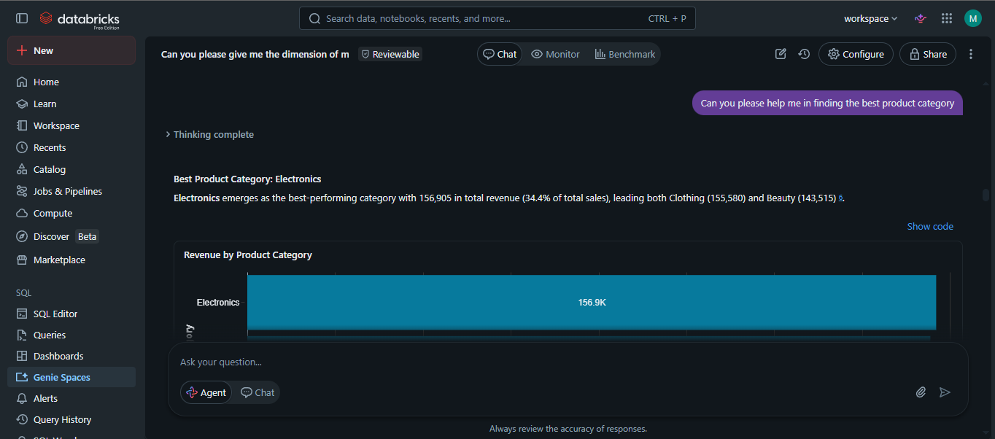
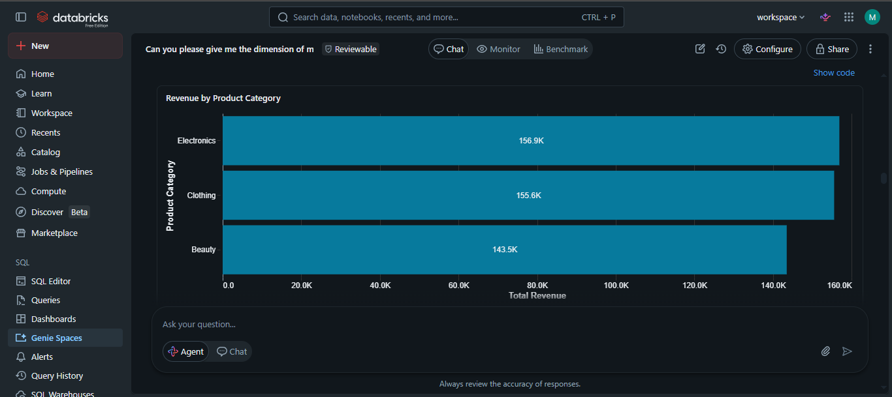
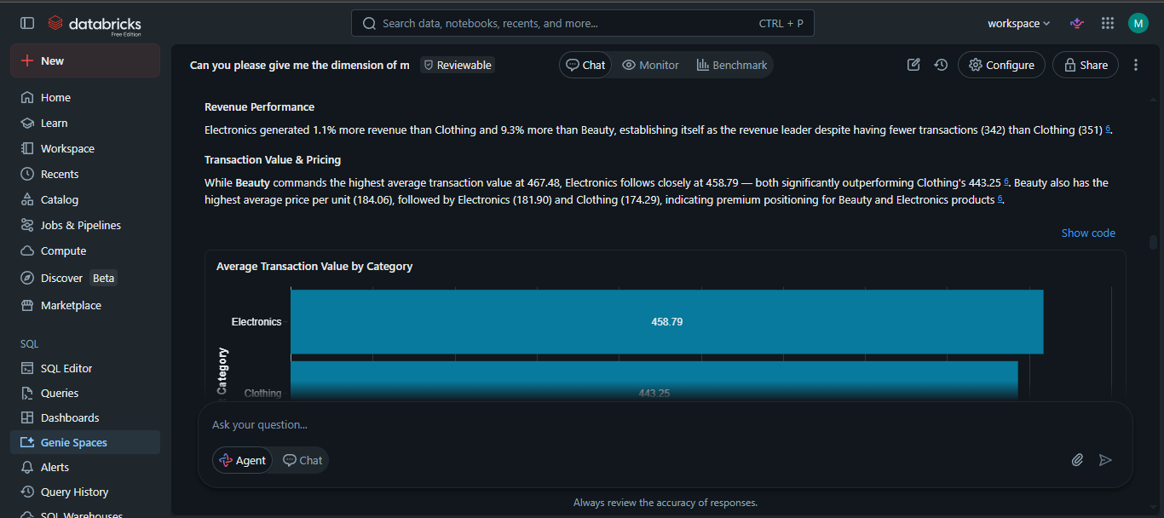
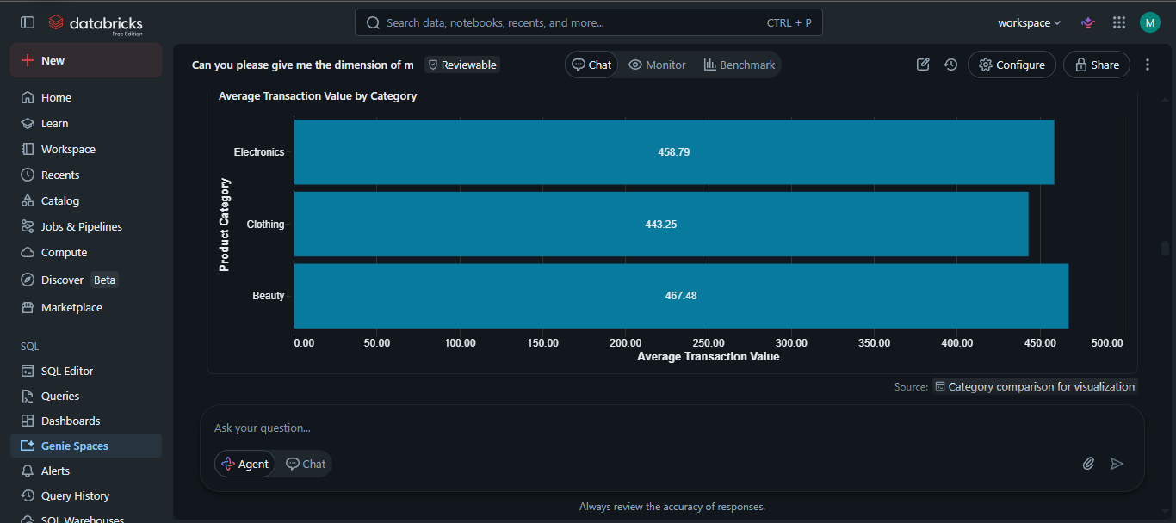
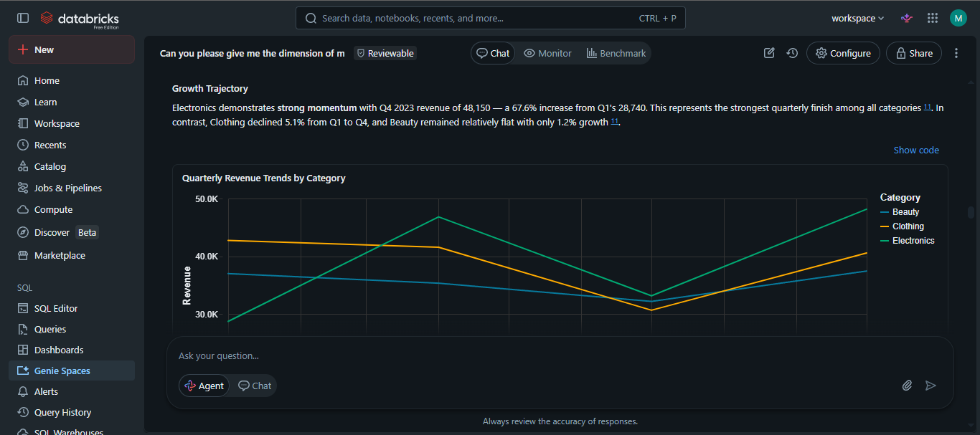
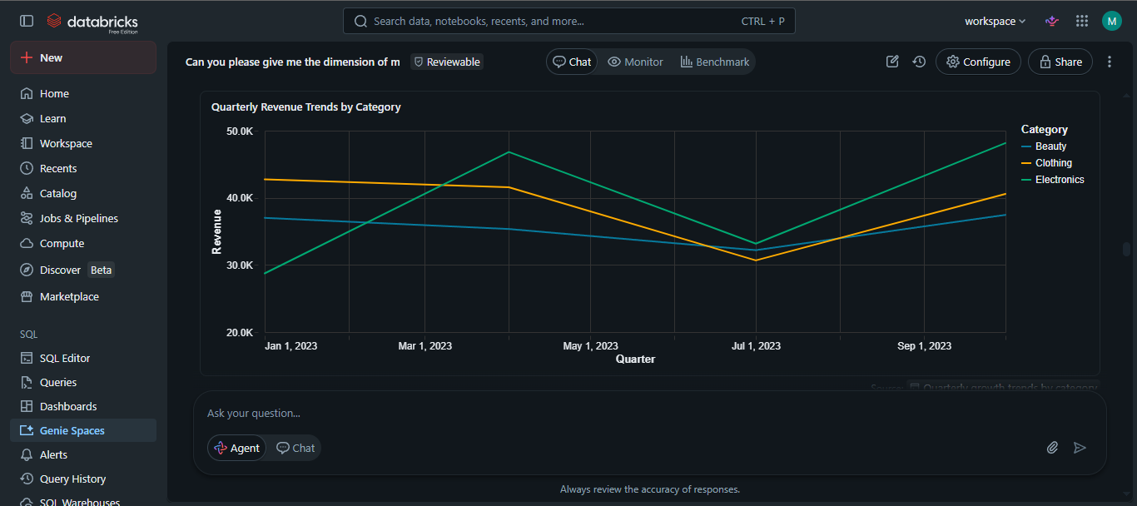
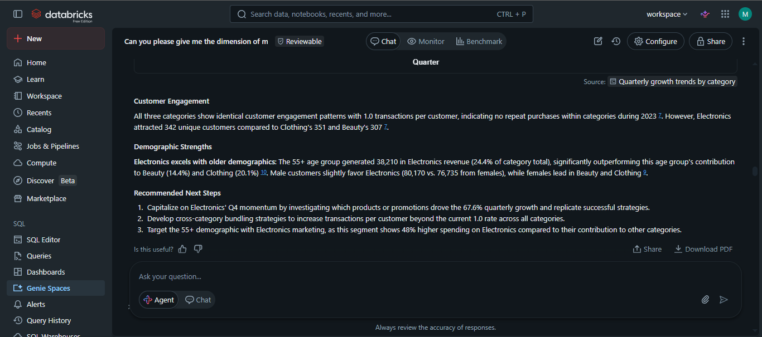
Question 7
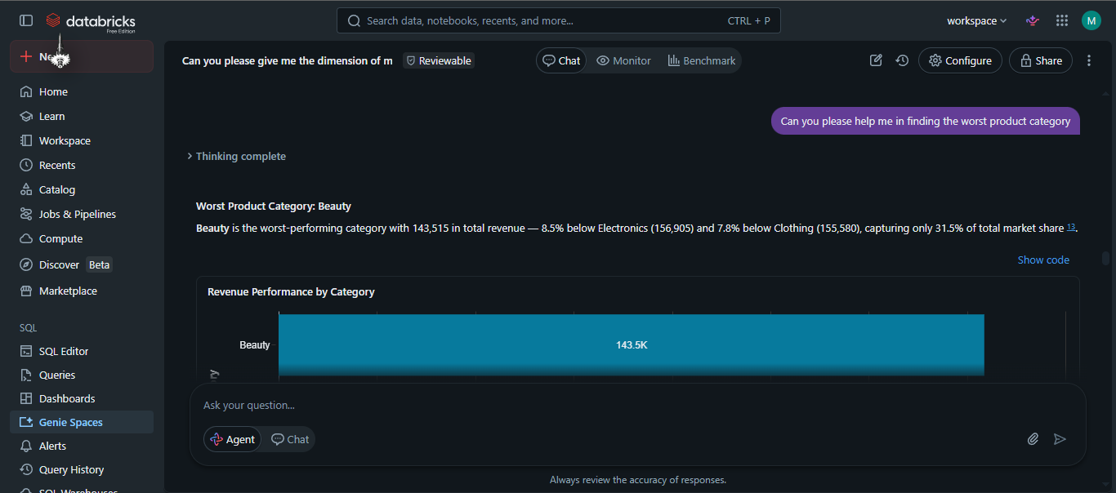
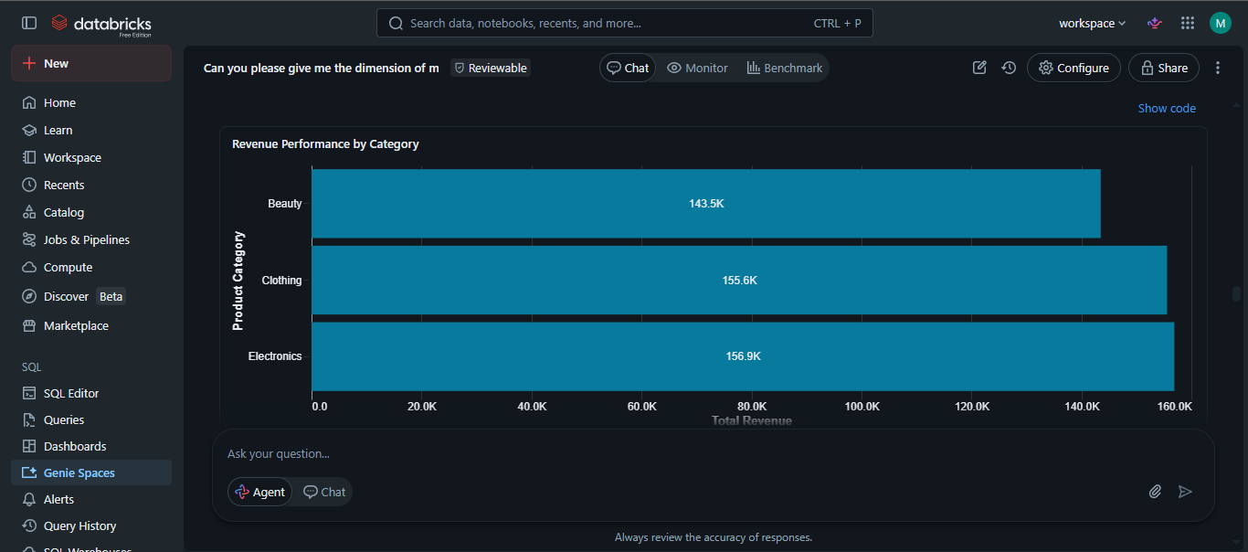
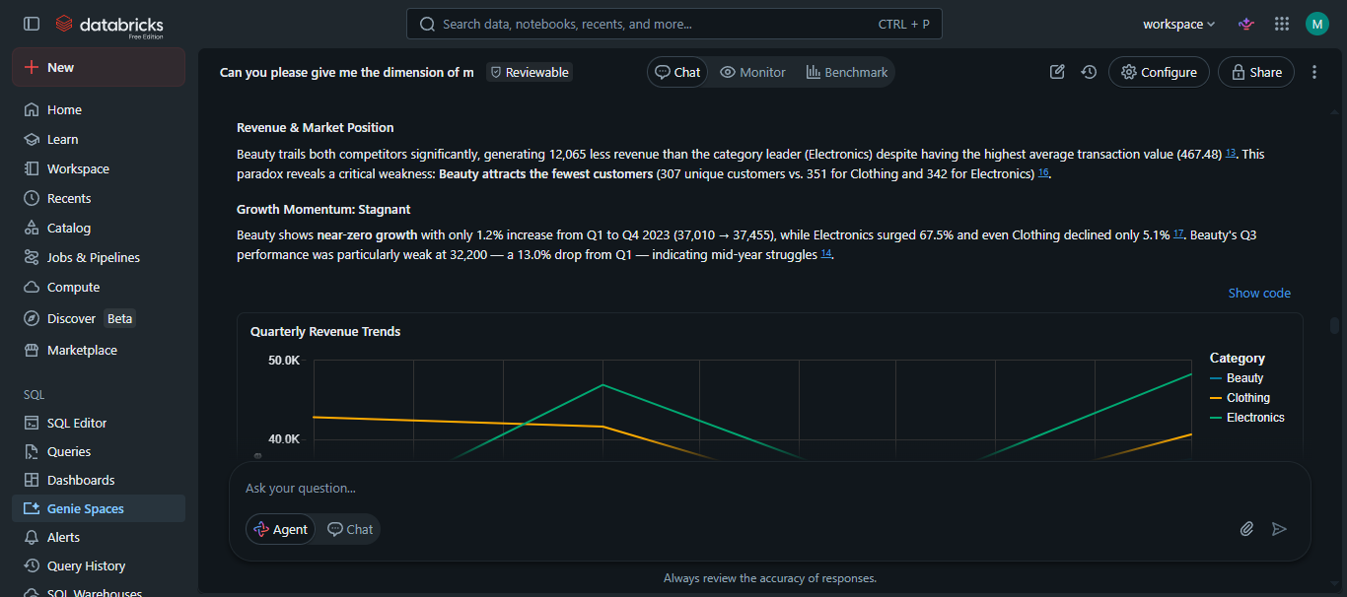
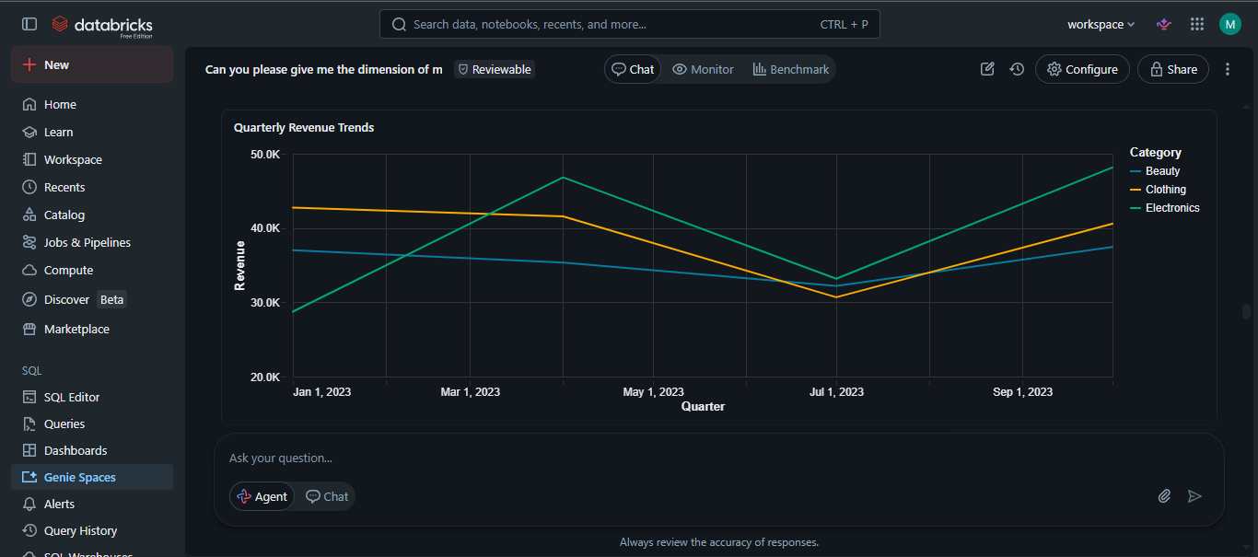
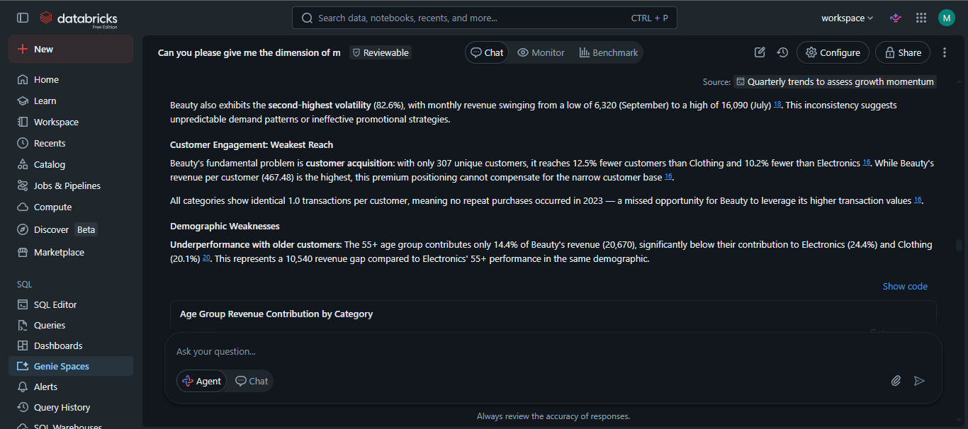
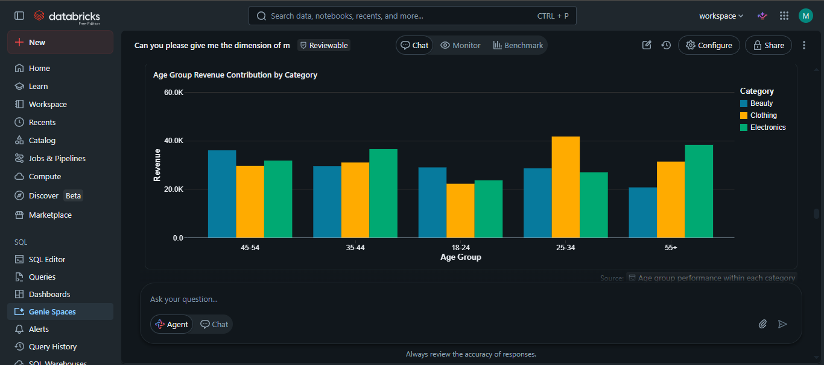
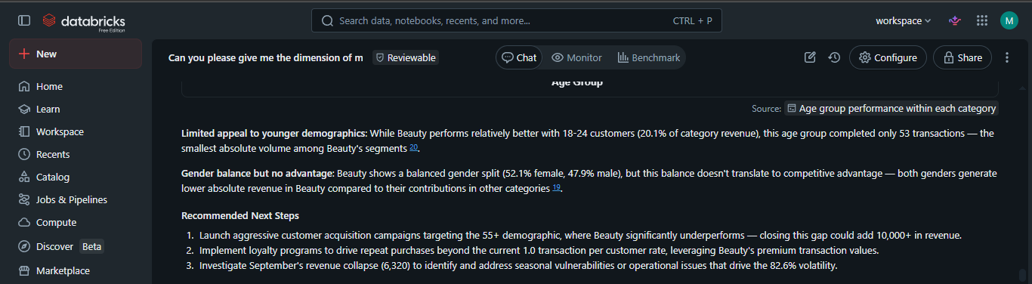
Question 8
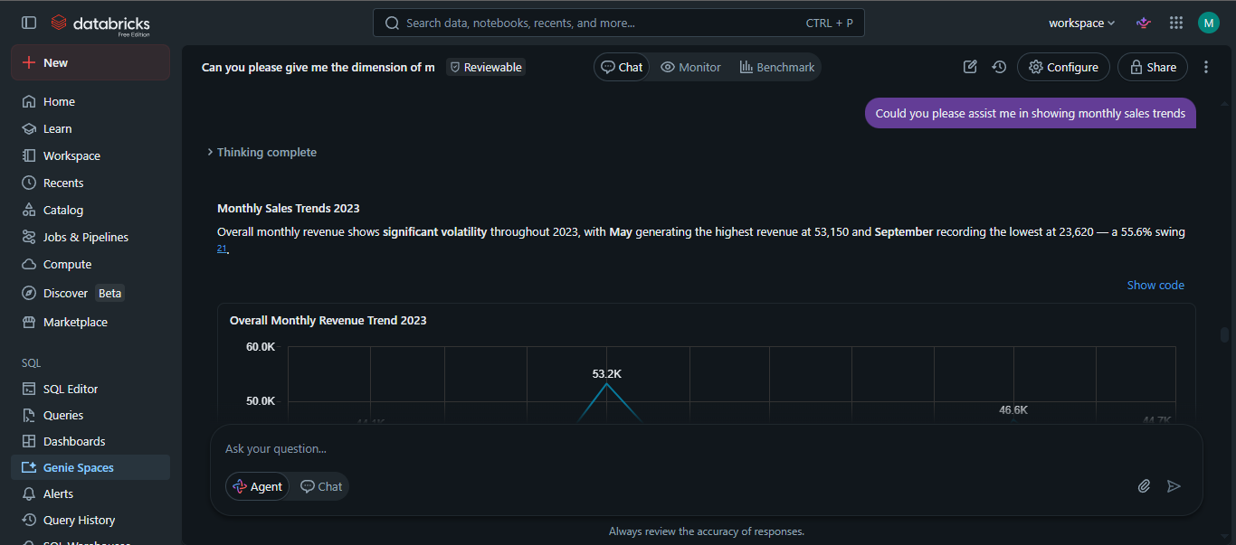
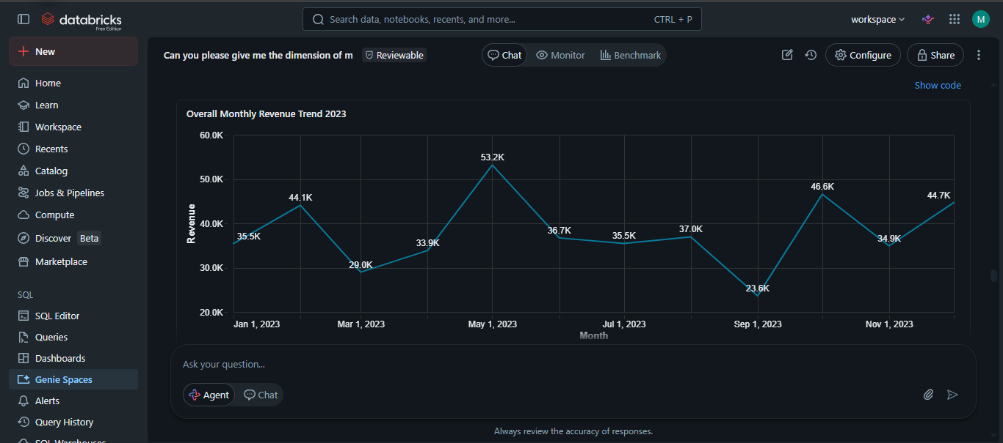
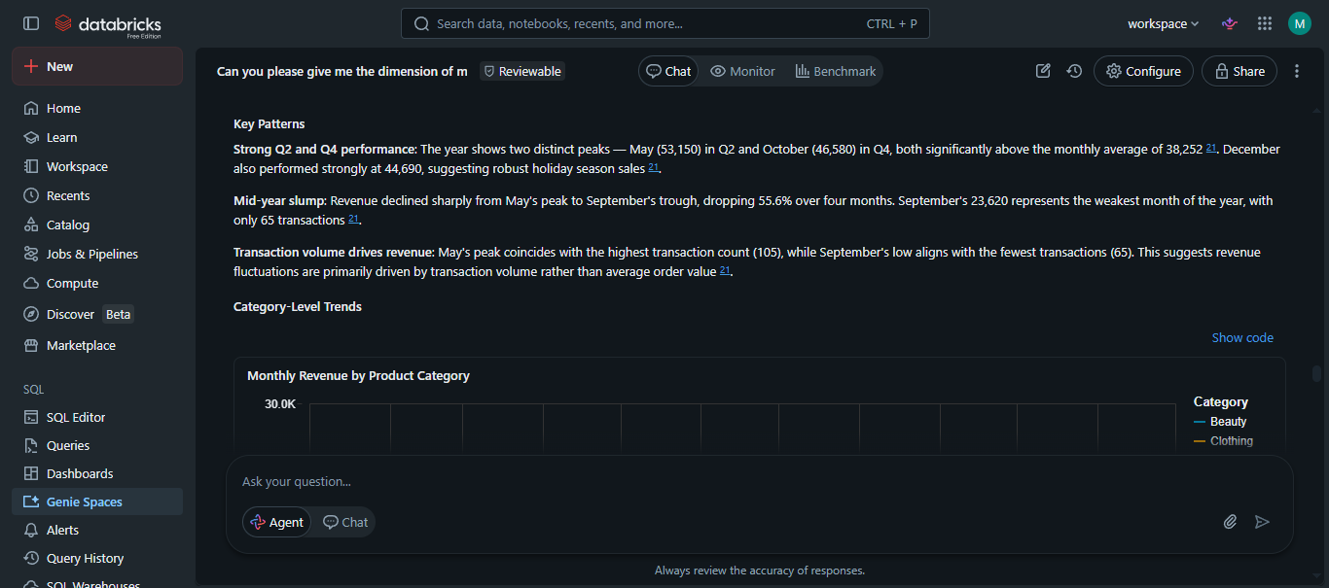
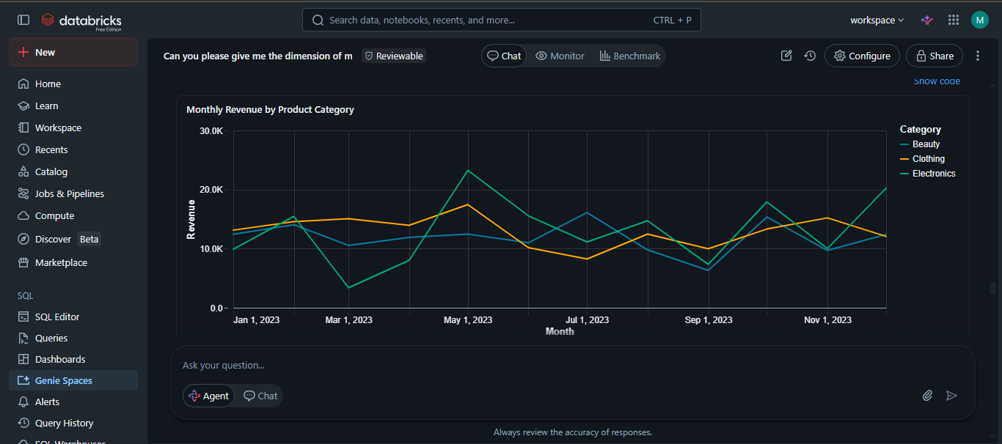
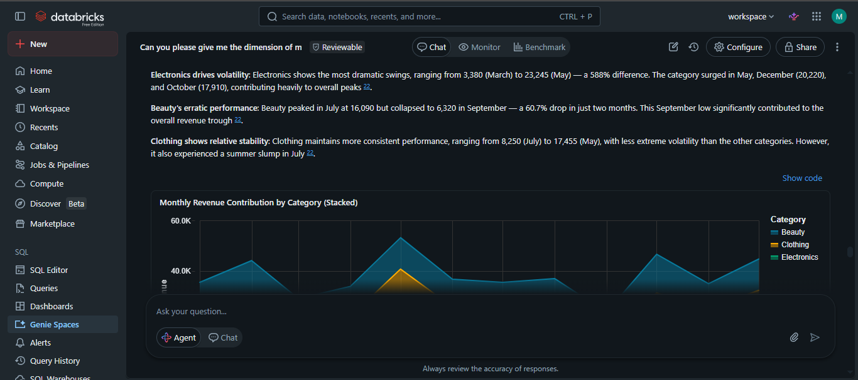
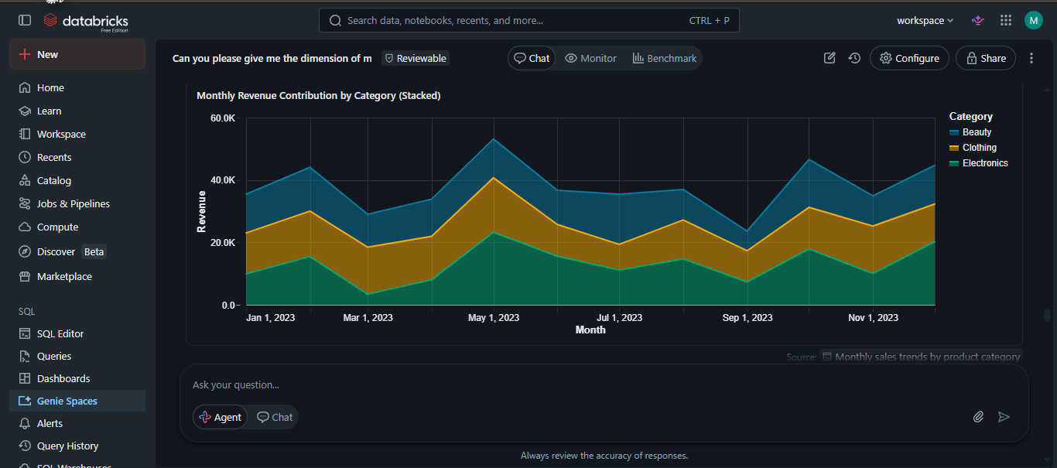
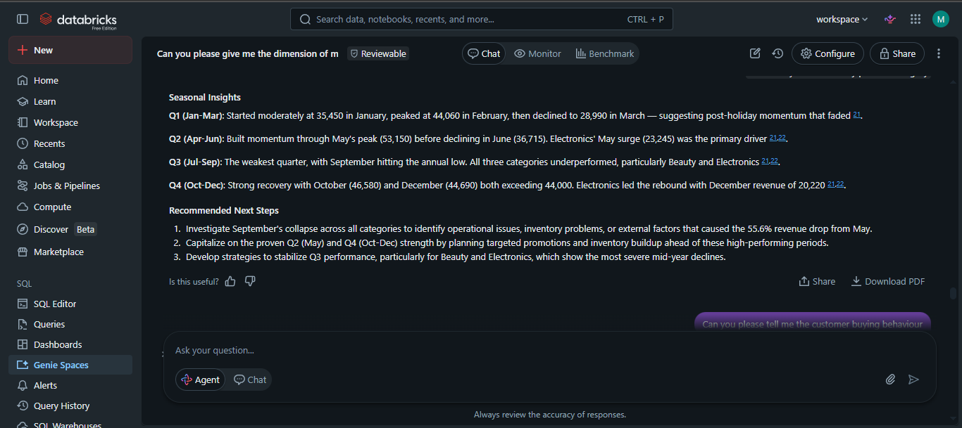
Question 9
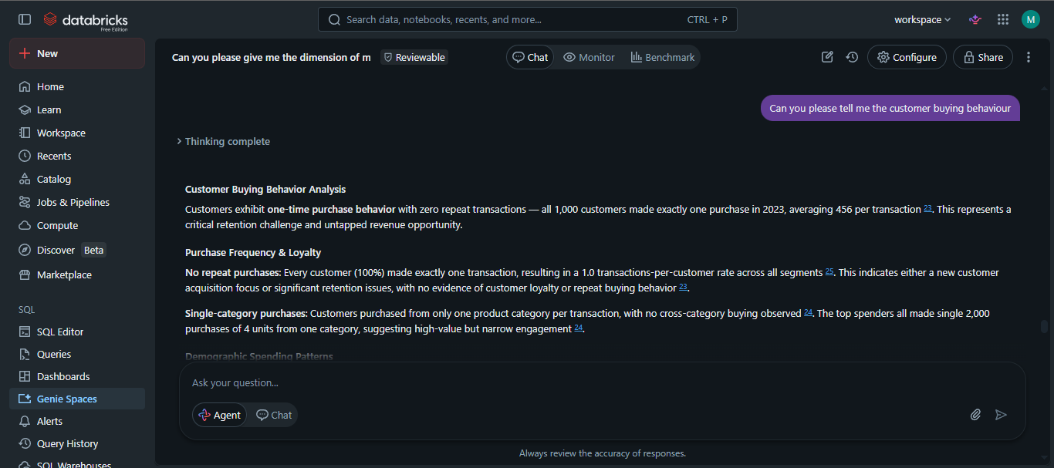
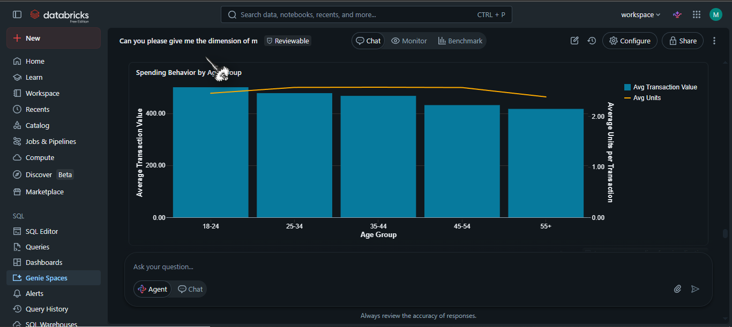
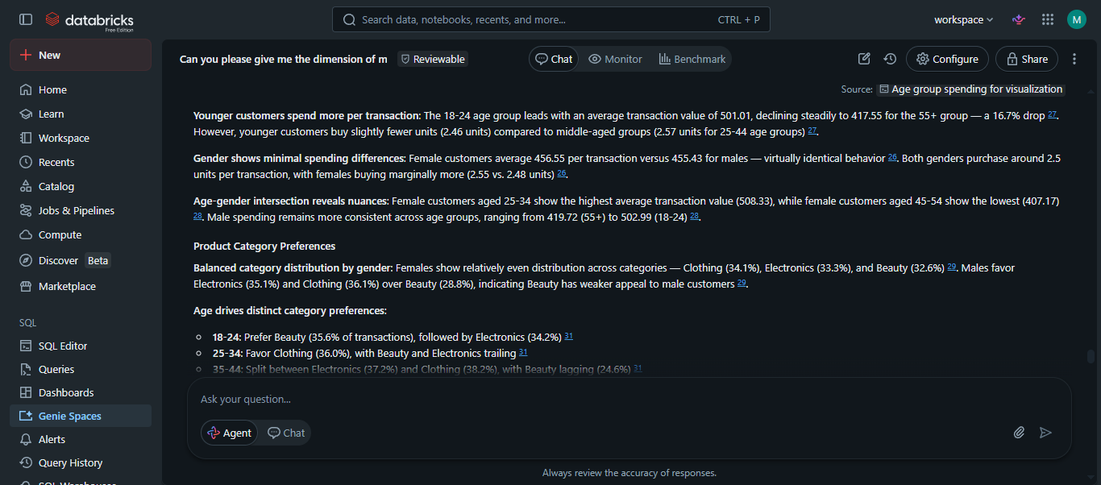
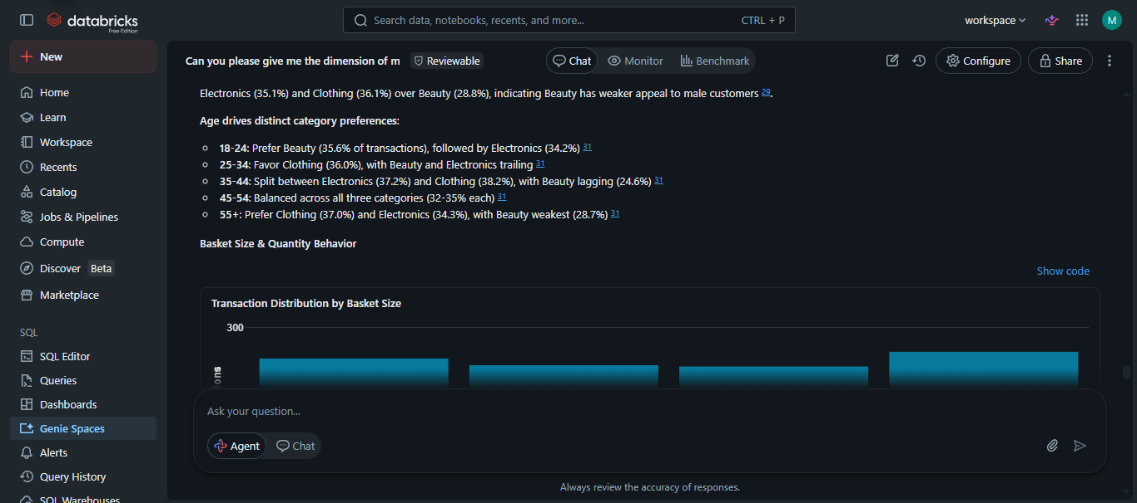
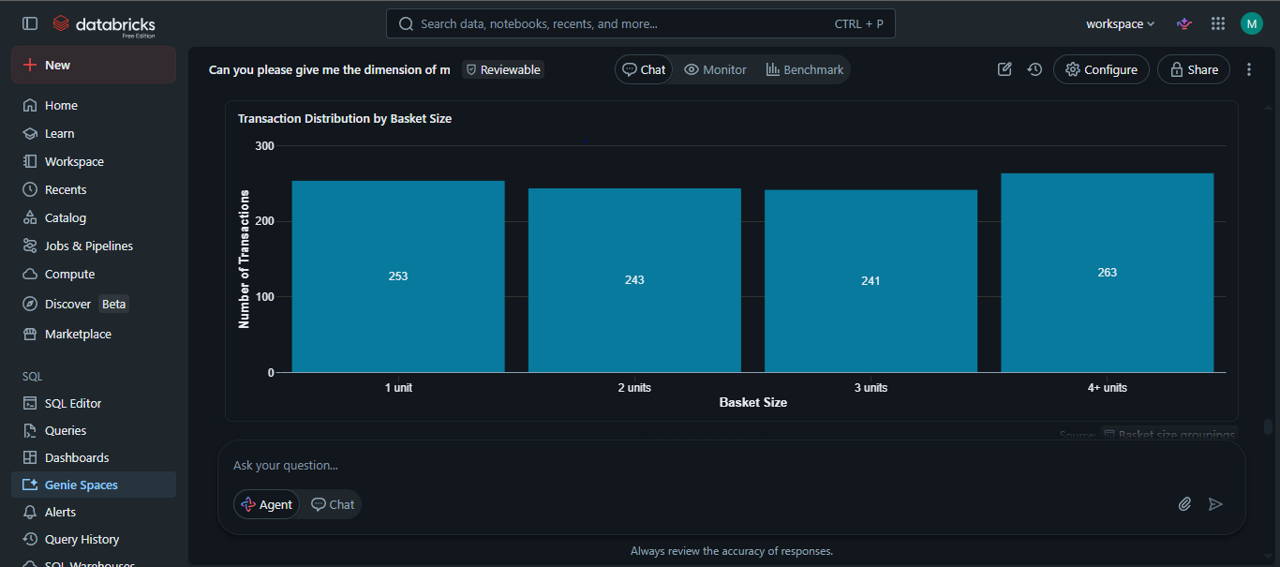
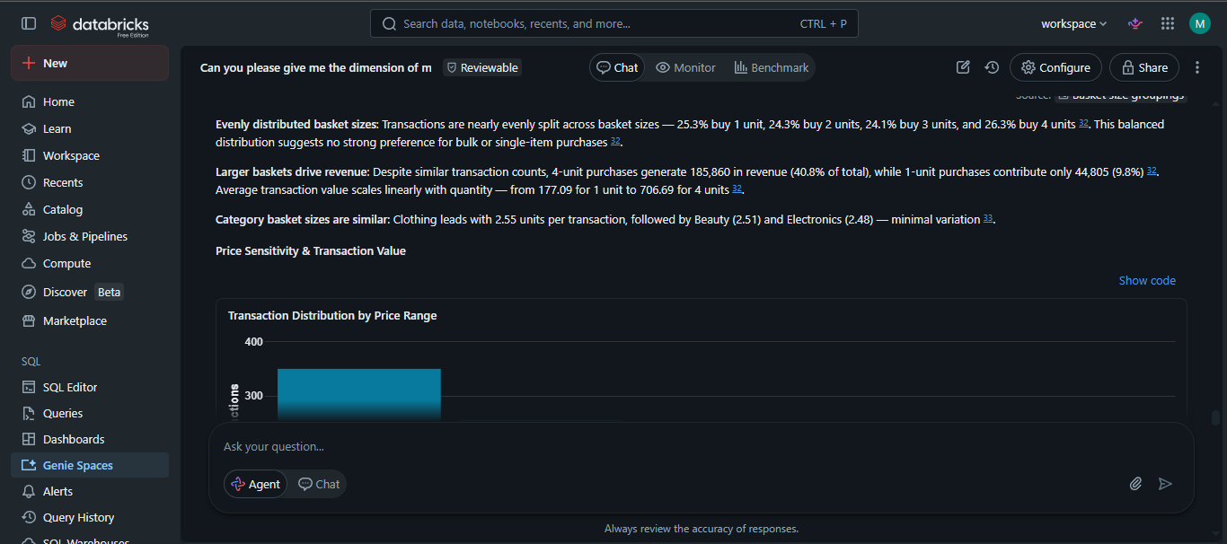
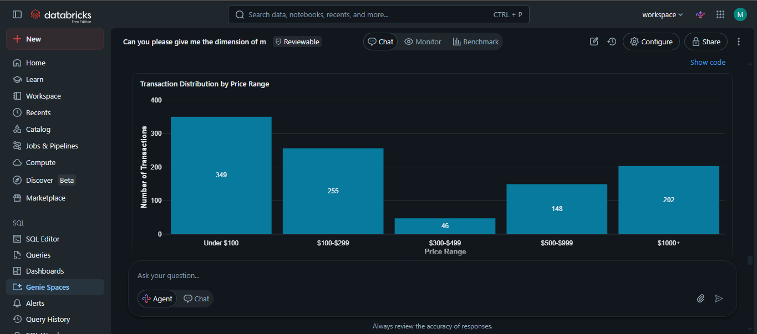
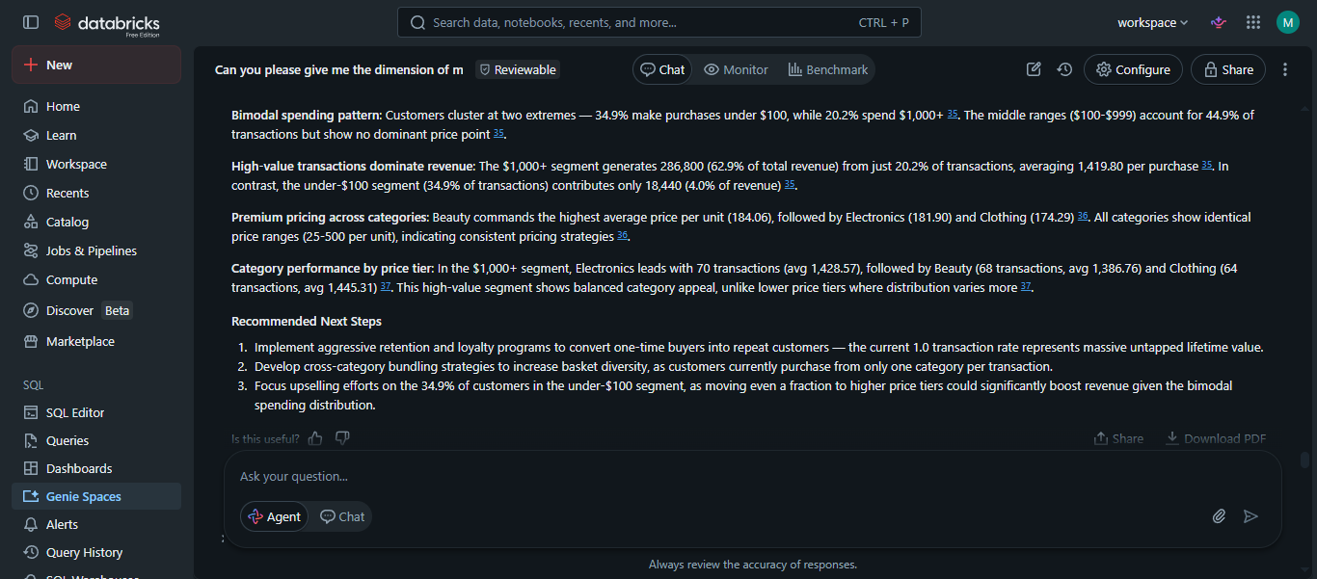
Question 10
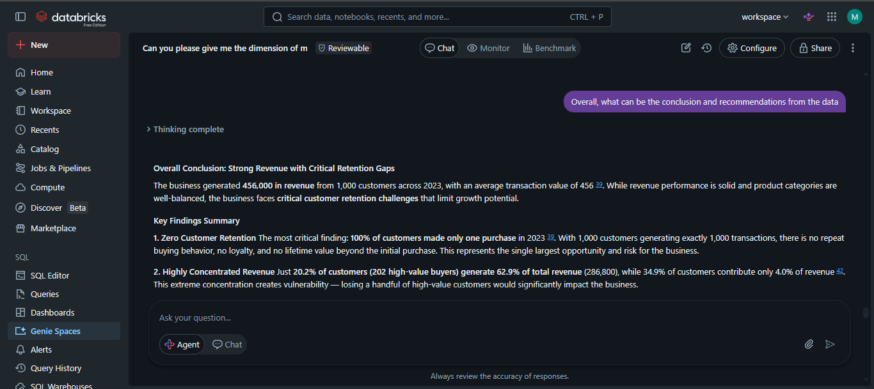
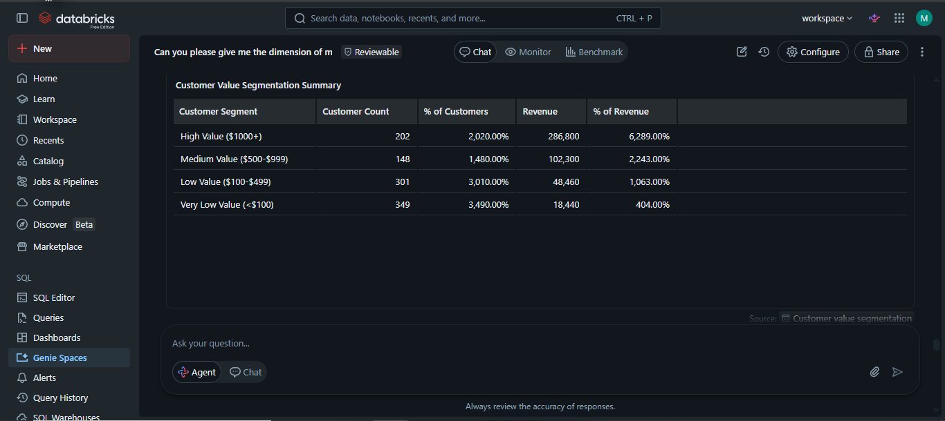
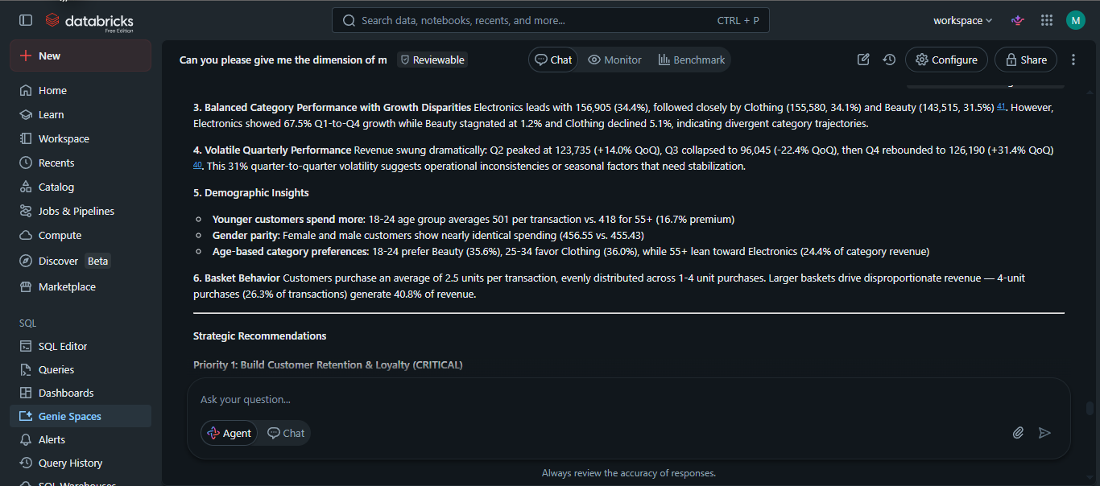
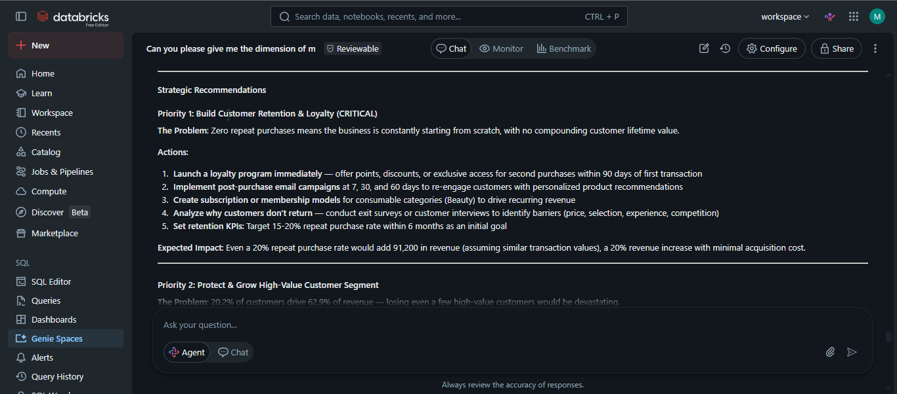
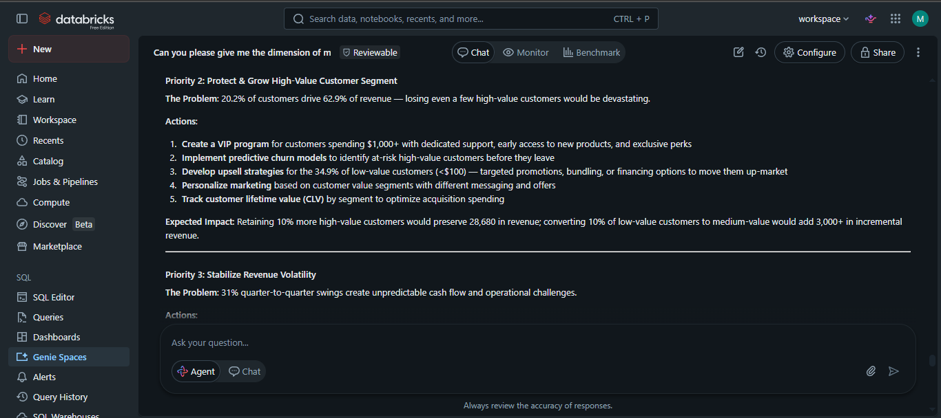
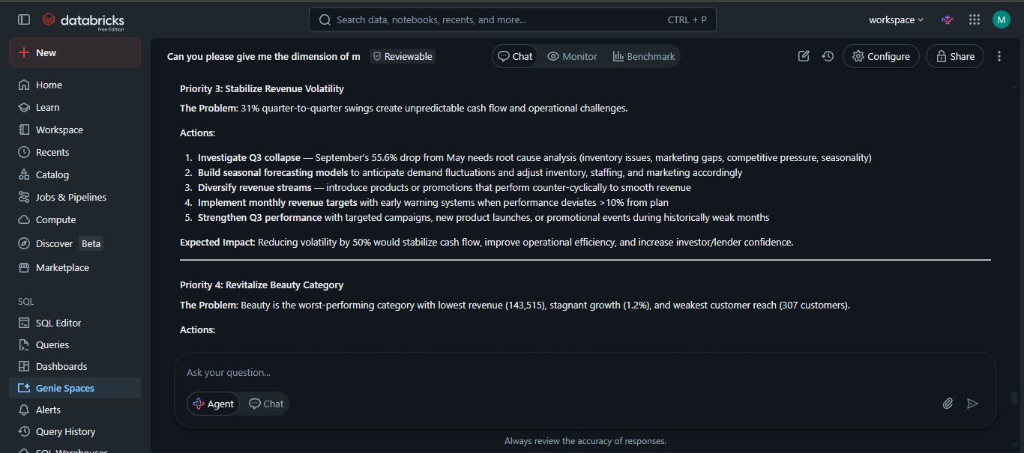
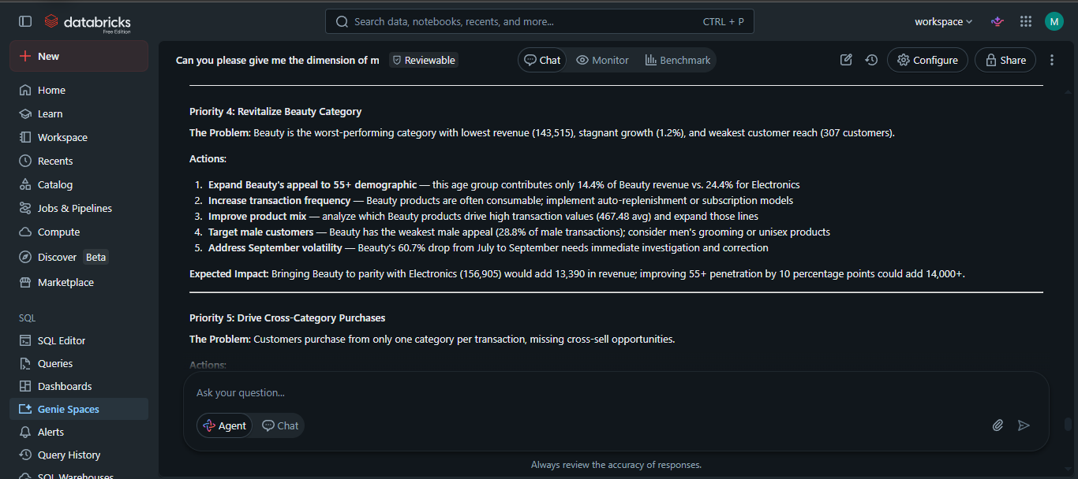
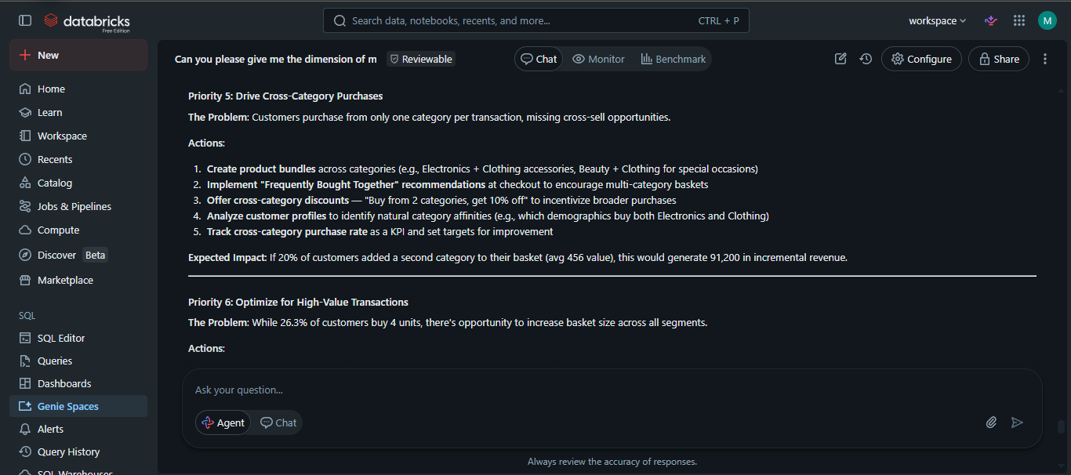
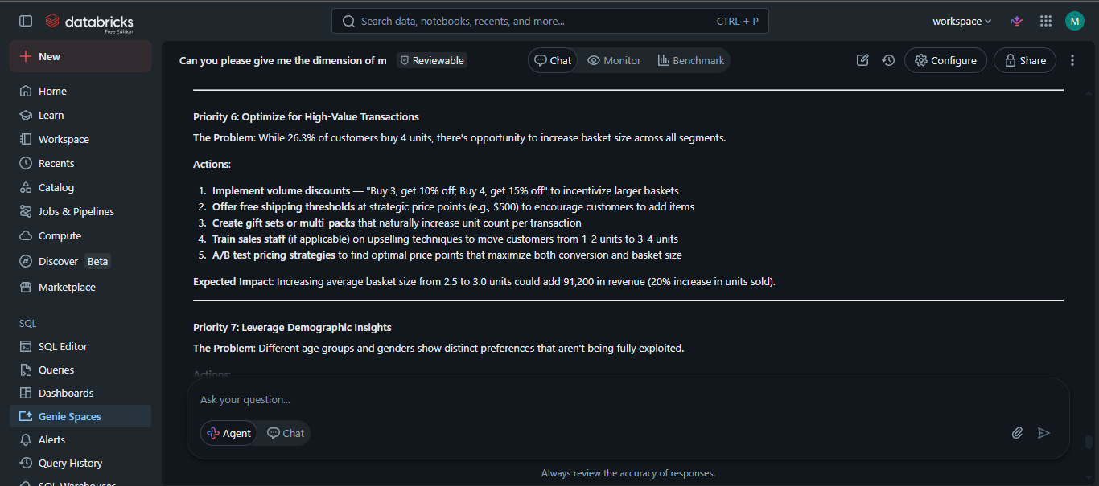
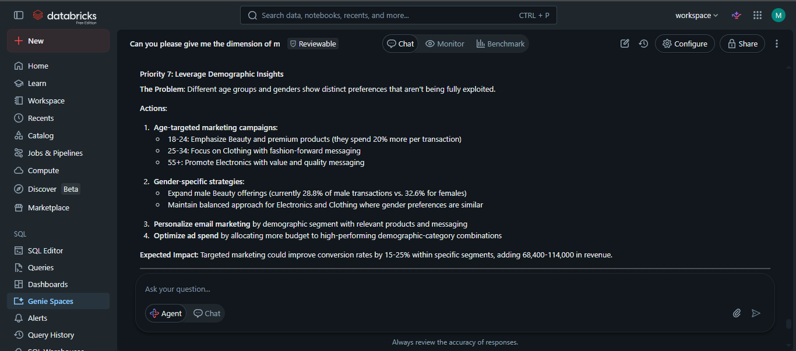
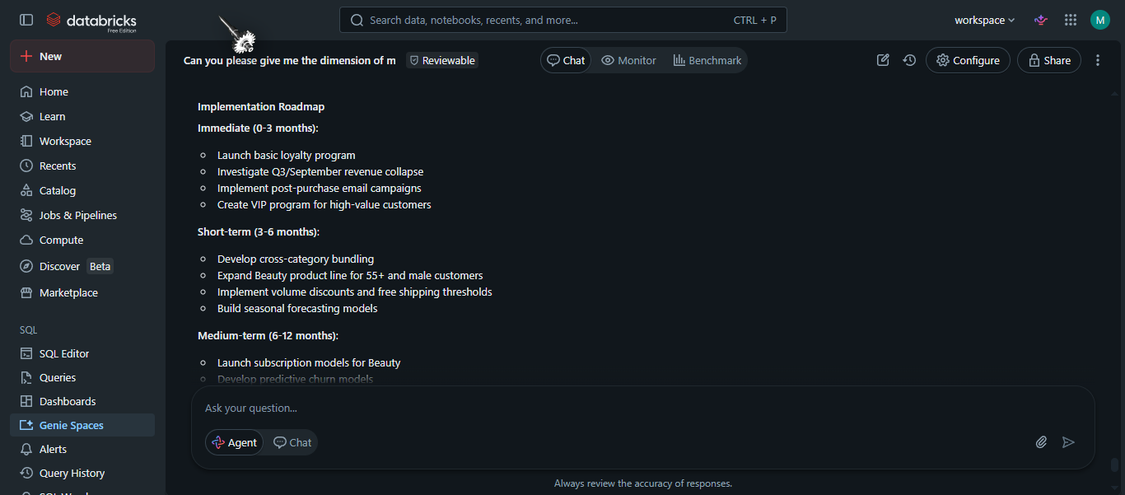
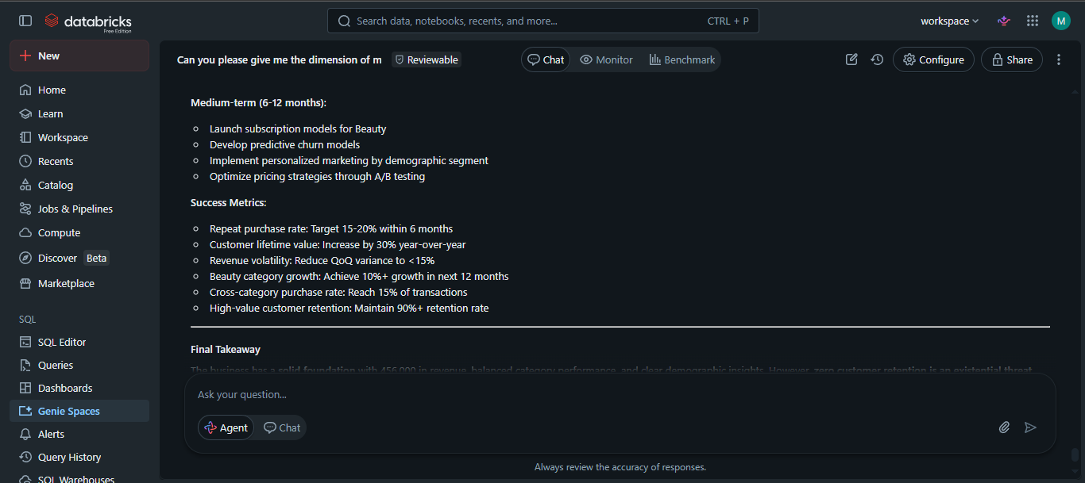
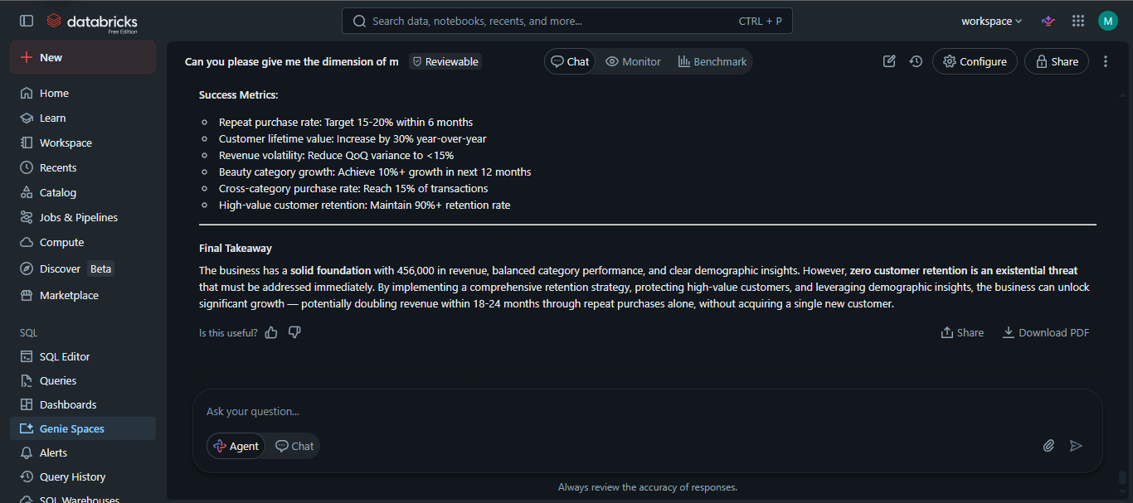
Step 7
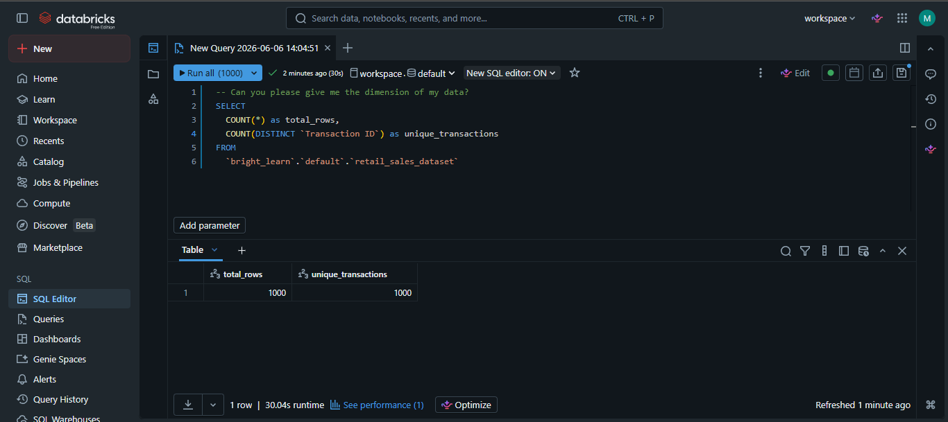
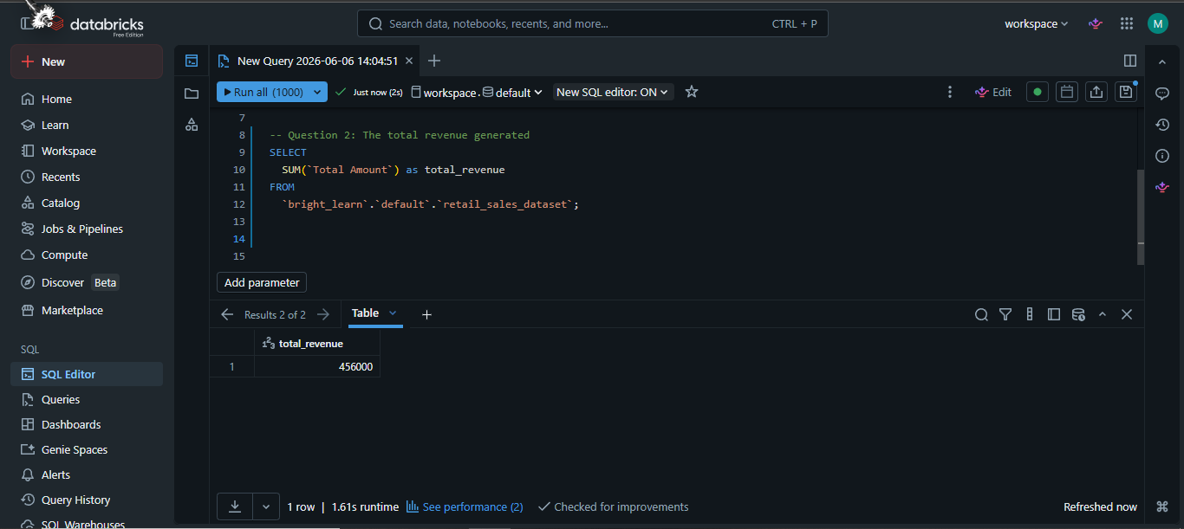
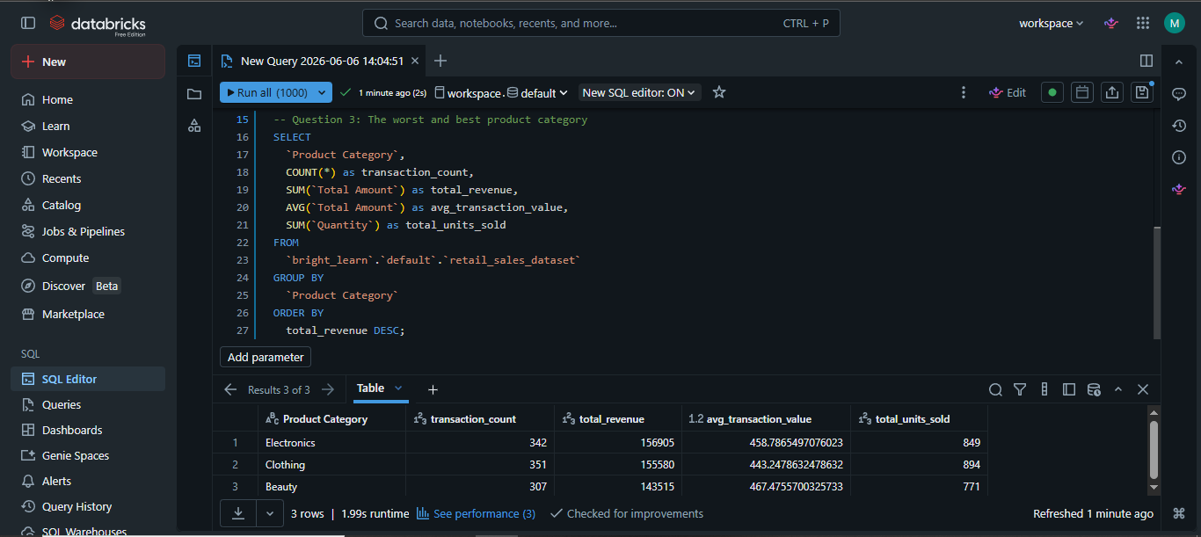
GitHub repository: https://github.com/MasekoNP/Retail_sales_data_agent.git

